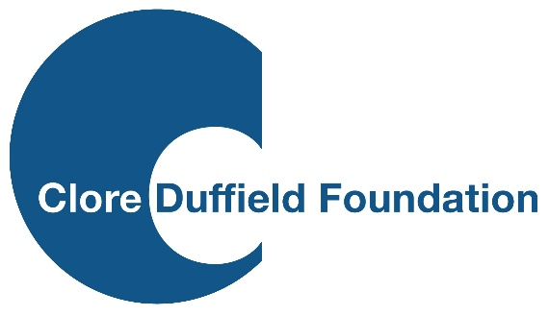
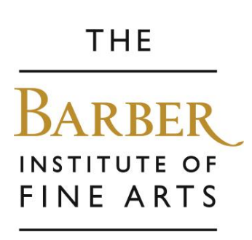


PRESS RELEASE
THE BARBER SELECTED FOR NATIONAL PROGRAMME TO BRING MORE BIRMINGHAM SCHOOLCHILDREN CLOSER TO ART
Children across Birmingham will have more opportunities to discover the power of art and explore their creativity. The Barber Institute of Fine Arts, University of Birmingham, joins a select group of five cultural organisations chosen nationally for Clore Schools Connect.
Funded by the Clore Duffield Foundation, the ambitious three-year programme will help the Barber build deeper, longer-term relationships with teachers and Birmingham schools whose pupils face barriers to cultural engagement.
The Barber is delighted to share learning with the four other partners in this new programme and thanks the Foundation for its support in making this work possible.
The Barber’s programme aims to:
- build lasting partnerships with Birmingham schools: with a focus on inclusion, teacher development and supporting pupils with special educational needs and disabilities (SEND).

- break down barriers to culture in the region: just 30% of state schools in the Midlands expect to take three or more trips out of their school settings per year, the UK’s lowest rate*.
With school budgets under pressure, opportunities for children to experience museums, galleries and the arts are increasingly under pressure. Through Clore Schools Connect, the Barber will work closely with teachers to understand pupils’ needs, develop and test new approaches to school engagement, and create stronger connections between classroom learning and the gallery. The aim is to build lasting relationships with schools and ensure more children feel that museums and galleries are places where they belong.
A key focus of the programme is to make the Barber’s work with schools more inclusive for children and young people with special educational needs and disabilities (SEND). Grace Mahar, formerly deputy headteacher at Fox Hollies School, is joining the Learning and Engagement team to support the development of a bespoke SEND programme and embed inclusive approaches across the Barber’s work with schools. Consultation and feedback from teachers and pupils will be central to shaping activities, adapting spaces and understanding what makes a visit welcoming, accessible and rewarding.
The programme comes at an important moment for the Barber as it prepares to re-open its doors in the latter part of 2027. Its building transformation, including improved level access, a new accessible learning wing and the Clore Learning Studio, will create opportunities to welcome more school groups and rethink how pupils experience the collection. The Barber strives to become a more welcoming, inclusive and responsive museum, connecting its world-class collection with more young people across Birmingham.
The Barber joins four other cultural organisations in the Clore Schools Connect cohort: the Royal Shakespeare Company, London Symphony Orchestra, Historic Royal Palaces – Hillsborough Castle and Gardens (Northern Ireland) and Turner Contemporary in Margate.
The Barber’s Head of Learning and Engagement, Flora Kay, said:
“Over the coming years, the new creative curriculum will present a transformative opportunity for cultural institutions to re-imagine how they support schools and importantly, art educators. This programme allows us to interrogate how the Barber can best respond to the evolving needs of our primary, secondary, and specialist settings.
“We aren't just creating gallery workshops – we hope to develop initiatives like vital, free professional development opportunities that respond directly to classroom realities and empower teachers in accessing galleries and creative practice. With our new spaces and programme, I hope our local schools will see the Barber as an inspiring and welcoming place for them.”
The Barber’s Director, Professor Jennifer Powell, said:
“We are delighted to be chosen as a partner in the Clore Schools Connect programme and to be developing our work alongside four peer organisations across the UK. Expanding the Barber’s schools’ programme with a focus upon creating supported opportunities for children who face barriers to accessing culture, and enabling SEND visitors to access and enjoy our world-class collection, are central to our mission. We thank the Clore Duffield Foundation for this unique and timely programme for Birmingham’.
Kate Bellamy, Director of the Clore Duffield Foundation, said:
“We are proud to support the Barber as one of the five participating organisations in the new Clore Schools Connect programme. Its commitment to inclusion and to building lasting relationships with Birmingham schools reflects the programme’s ambition to help more young people experience and enjoy arts and culture.”
* Research conducted in March 2026 by Teacher Tapp on behalf of the Clore Duffield Foundation. 9,722 teachers responded to the survey.

NOTES TO EDITORS
HIGH RESOLUTION IMAGES FOR MEDIA USE CAN BE DOWNLOADED HERE
The Barber Institute of Fine Arts is the art gallery, principal art collection and original concert hall for the University of Birmingham. It was founded in 1932 ‘for the study and encouragement of art and music’ by Lady Barber, who stipulated the acquisition of works ‘of that standard of quality required by the National Gallery and the Wallace Collection’. Housed in Birmingham’s most significant Art Deco building, designed by Robert Atkinson, the Barber Institute is home to a National Designated Collection, acquired and owned by the Henry Barber Trust and with holdings that now include some 160 paintings, dating from the early Renaissance through to the late 20th century, more than 800 works on paper, as well as sculpture, decorative arts and one of the most important caches of Roman, Byzantine and Medieval coins in the world. The collection features key works by (among others) Giovanni Bellini, Sandro Botticelli, Rosalba Carriera, Edgar Degas, Thomas Gainsborough, Gwen John, Käthe Kollwitz, René Magritte, Edouard Manet, Claude Monet, Auguste Rodin, Peter Paul Rubens, JMW Turner, Vincent van Gogh, Elizabeth Vigée Lebrun and James McNeill Whistler. For more information, visit barber.org.uk and follow @barberinstitute on X (formerly Twitter), Instagram and Facebook for regular updates, news and opportunities to engage with the Barber.
The Clore Duffield Foundation was established by Sir Charles Clore in 1964 and is now chaired by his daughter, Dame Vivien Duffield. It supports UK charities working in the arts, education, social welfare and health. The Foundation enhances Jewish cultural life through support for JW3, the Jewish arts and community centre in London.
Since 2000, the Clore Duffield Foundation has provided funding to support the development of Clore Learning Spaces in museums, theatre and heritage sites across the UK. We have funded around 80 Clore Learning Spaces with grants of up to £2.5m to create Clore Learning Centres in national museums and performing arts centres, to donations of less than £50,000 to fund small Clore Studios within local museums and libraries.
The Foundation has launched Clore Schools Connect to support organisations with Clore Learning Spaces to develop and deliver innovative programmes for state-funded primary and secondary schools facing barriers to cultural engagement.
The grant programme is designed to support organisations to test and innovate new approaches to developing and sustaining engagement with hard-to-reach schools. The programme aims to allow organisations to make a significant step-change in their current engagement with schools.
FOR MORE INFORMATION
Andrew Davies, Communications and Marketing Manager, the Barber Institute of Fine Arts – andrewdavies@barber.org.uk / 0121 414 2946.

