Unstill Life: Global Mobility and Consumerism in Still Life Paintings

Natasha Wilcockson

The Arts Society Collections Intern

June 2024

Introduction
Still lifes typically depict a diverse arrangement of natural and man-made objects in an interior setting. This genre became immensely popular among European artists and patrons during the seventeenth century, particularly across the Netherlands. Dutch and Flemish artists painted illusionistic textures and surfaces, providing their audiences with luxury ‘slices of life’ and often punctuating their works with religious and allegorical symbolism. Highly sought-after, these still lifes played a critical role in the birth of the commercial art market and could fetch more than a work by Rembrandt. This acclaim endured for more than a century before collapsing almost completely. A resurgence of interest in the twentieth century saw the European avant-garde harness the genre as a means of formal experimentation.
Still lifes are conventionally perceived as impressive assortments of ‘inanimate’ objects. In 1649, Leiden artist David Bailly was considered a very good painter ‘en vie coye’ – of ‘quiet’ or ‘immobile’ life – and in general, early still lifes were referred to by the Latin word inanimatus. A general understanding of these artworks as static has remained commonplace in historical narratives, which tend to offer inward focus on technique and symbolism, or emphasise the historical context of the Protestant Reformation and its impact upon pictorial practice. Twentieth-century still lifes, too, have often been interpreted using a Formalist framework (focusing on surface details such as style, composition, and texture) or considered with reference to socio-political changes in Europe. This curatorial project applies a broad transnational perspective to four still life paintings: Jan Davidsz de Heem’s Still Life with a Nautilus Cup (1632), Maria Tassaert’s Still Life with a Garland of Fruit (1660s), Max Pechstein’s Still Life in Grey (1913), and Fernand Léger’s Composition with Fruit (1938), arguing that they are in fact distinctly ‘Unstill’ and offer insight into changing global attitudes over time.
Conceptualising still life paintings as completely ‘immobile’ shrouds a crucial aspect of their history: the expansion of empire, global trade, and consumerism. The emergence of the Dutch still life genre coincided with the acceleration of trade with the New World, Africa, East and South East Asia, and India. The Dutch East India Company (Vereenigde Oostindische Compagnie or VOC) was a ‘war machine, a quasi-state’ that enjoyed a monopoly over trade with Asia. ‘Rarities’ such as spices and precious gems from India, silk and porcelain from China and Japan, and fruits and wine from across the Mediterranean flowed into Dutch ports through a cross-hatched network of maritime transport routes. Meanwhile, the VOC’s Atlantic counterpart, the West India Company, had colonies in Brazil, Curaçao (a Caribbean island), and Suriname (a country in South America). These colonies brought precious goods such as sugar, tobacco, and hardwoods. Powered by mercantile capitalism, the Dutch Republic was the ‘undisputed boss of global trade’ and quickly became the richest nation in Europe. Yet such wealth was achieved at great human and environmental cost. The colonial enterprise relied upon the exploitation of distant territories and resources, the suppression of local populations, and the use of slave labour. Sailors (usually recruited from the Netherlands’ lowest classes) also frequently ‘paid with their lives’, with only half returning from the treacherous voyage to Asia over the entire life of the VOC.
Colonial exploits were far removed from daily life in the Netherlands, where ‘exotic’ treasures piled into the curiosity shops of Amsterdam and Leiden as a taste for foreign, finer things developed. In this ‘republic of rarities’, luxury goods were collected by the upper classes as a self-fashioned mark of internationality. Still lifes then exemplified these conspicuous collecting practices and immortalised ‘Golden Age’ abundance through remarkable mimetic techniques.
***

Jan Davidsz de Heem (1606 – 1683/84), Still Life with a Nautilus Cup,

Leiden, Dutch Republic (The Netherlands), 1632
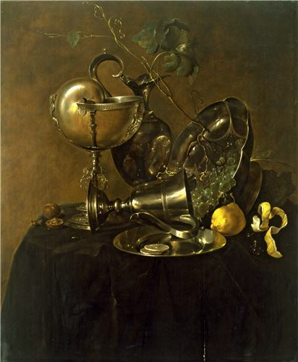
Jan Davidsz de Heem was born in 1606 in Utrecht to a family of Flemish descent. He moved to Leiden in 1625 and his earliest known still lifes are dated from 1626. This painting, which is an example of a rare early ‘breakfast piece’ (or ontbijtje), depicts a Nautilus-shell cup in a silver mount, a fallen silver cup, a lobed pedestal bowl, a ewer, a tin plate, a grapevine, some walnuts, and a sliced and peeled lemon (or perhaps a quince). The play of light on these hyper-realistic organic and inorganic surfaces reveals de Heem’s virtuosic technical skill. The Nautilus shell, fallen ewer, and grapevine form a triangular structure whilst a complex pattern of curls and scrolls weaves throughout the composition. Through ‘elaborately staged disorder’, de Heem achieved both counterpoint and unity in this compelling image of refined Dutch taste.
A Still Life with a Nautilus Cup marks a critical juncture in the artist’s oeuvre. As with the artist’s style of the late-1620s, the deceptively simple composition and largely monochrome grey-brown tonality of this work shows the influence of Haarlem still life artists such as Pieter Claesz (1597-1661) and Willem Heda (1594-1680). However, the painting also evidences de Heem’s artistic shift towards the vibrant, elaborate, and sumptous banquet pieces (pronkstillevens) that would characterise his practice from the mid-1630s. These theatrical still lifes displayed luxury objects in profusion (often depicting shells, parrots, silks and lobsters), and thus overwhelmed viewers with visions of wealth and abundance.
The Barber painting conveys de Heem’s growing enthusiasm for Dutch imperial collecting practices. Giant shells were collected by VOC merchants from the Indian Archipelago. They were then often exported to Asia to be stripped and etched before being sold on to Europe and gilded. Transported across vast oceans, de Heem’s Nautilus cup draws attention to the unmatched sea power of the Dutch republic. It also celebrates the process of transforming foreign (and once living) materials into decorative Dutch possessions. The shell operates within multiple shifting contexts: as a creature, a transported good, and the prized possession of a collector’s curiosity cabinet. De Heem’s ‘trick of the eye’ Nautilus cup thus captured and celebrated the vibrant aura of this object’s exoticism.
The lemon (or quince) offers further insight into the painting’s global influence. Citrus trees did not grow easily in the bitter climate of the Low Countries, so their fruits were imported. One of the geographical sources of lemons was Dutch Brazil, where enslaved African people worked on plantations to harvest the citrus that would be marvelled at in still lifes, candy the peel that would become a market delicacy, or pick the blossom that would be distilled into perfume. This period also saw the growth of botanical gardens, hothouses, and orangeries, where the wealthy would admire foreign ‘specimens’ and develop their knowledge of the natural world. The bright yellow citrus in this otherwise muted work, treated with subtle impasto, ‘appears like a foreign exclamation mark’. Walnuts were another luxury beyond the means of the majority of the population. They were traded along the Silk Road for millennia, planted in the gardens of the Carolingian Emperor, Charlemagne (748-814), and introduced as paste in the recipes of the Middle East. The artist compliments the citrus and nuts with a vine of luscious green grapes – a nod towards the refined fruit of the wine-producing Mediterranean.
De Heem contrasts these organic goods with various silver vessels. The silver in this painting may have come from Germany, Spain, or even Spanish America, where the Dutch also owned mines. The Central and South American silver industry was violent. During the sixteenth and seventeenth centuries, Spanish colonists imposed a labour system known as the mita in Bolivia, in which Indigenous Incans and enslaved African people were forced to work the mines in brutal conditions and carry heavy loads of silver ore to the surface, a task that killed thousands. Yet from the Spanish colonial perspective, this silver provided the fluid capital that enabled the permanent global exchange of slaves, fabrics, porcelain, tea, and spices, leading many scholars to link the silver trade to the beginning of a genuinely global economy. Dutch still lifes often presented a complicated view towards these luxuries. As underlined by Alan Chong and Wouter Kloek, ‘the idea of luxury was full of contradictory associations of comfort and excess, as well as pride mixed with guilt.’ In this context, perhaps de Heem’s tumbled silver cup and overturned pedestal bowl symbolise the ephemerality of human pleasures and forewarn against excess. Yet at the same time, these objects give the painting an inviting just-walked in quality, and suggest the behind-the-scenes use and enjoyment of precious goods. Dutch viewers understood the newfound comfort, economic significance, and political independence behind ‘seemingly humble’ table settings. Grouped together in a pared-back setting, the variety of exquisite life-like objects on display seem to present a celebratory attitude towards the Dutch global enterprise.
***

Maria Tassaert, Still life with a Garland of Fruit,

Antwerp, probably 1660s
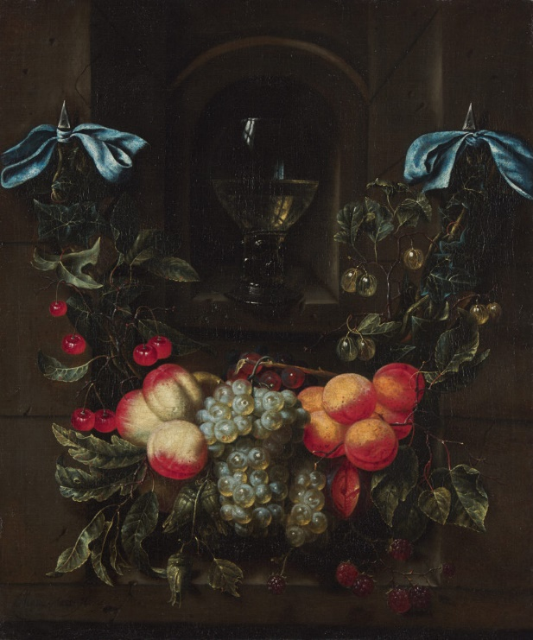
Maria Tassaert came from an extended family of artists, but little is known about her own life. She is thought to have trained under her father, Peeter (working 1630-92) and was active in Antwerp. This painting is her only known signed work and is part of a wider Flemish and Dutch tradition of such subjects.
Still Life with a Garland of Fruit depicts a garland of white peaches, nectarines, cherries, grapes, raspberries, gooseberries, a cut plum, cobnuts (a type of hazelnut), ivy, and fruit leaves. The garland is held up by blue silk ribbons and frames a stone alcove containing a (white) wine glass with a studded stem (known as a roemer), with a studio window reflected in the glass. Developed in the Catholic Southern Netherlands in the early seventeenth century, the garland genre originally consisted of a devotional image encircled by a luscious wreath of fruits and flowers. However, this iconographic function became fraught as the Protestant critique (and destruction) of representational religious imagery took hold. Some artists, like Tassaert, abandoned the genre’s religious focus in favour of emphasising display, abundance, and impressive illusionistic and mimetic techniques. By the 1630s, garland paintings had a ‘variety of uses’ and were incorporated into decorative domestic schemes, often framing fireplaces or placed on tabletops amongst an array of different objects.
As with de Heem’s Still Life with a Nautilus Cup, Tassaert’s garland painting divulges interesting transnational influences, albeit less explicitly. Tassaert lived and worked in Antwerp alongside still life artists such as de Heem (active in the city from 1636-58 and 1672-84), Daniel Seghers (1590-1661), and Frans Snyders (1579-1657). The port city quickly became the leading commercial centre of western Europe, trading goods such as textiles, spices, plants, and precious stones. Tassaert’s blue silk ribbons probably came from the VOC’s outposts in Bengal – a subtle detail that may have played into the internationalist and materialist psyche of her audience.
The garland itself tells another strand of the story. Unsurprisingly, the introduction of new plant-life to Antwerp provoked an intense interest in botany and horticulture. During the sixteenth century, wealthy merchants constructed country houses (maisons de plaisance) with beautiful botanic gardens in the environs of Antwerp, and the city became a cultural hub for the study of Naturalia well into the seventeenth century. Tassaert’s painting communicates this Netherlandish enthusiasm for botanical produce. Peaches, nectarines, and plums (which most likely originated in China before spreading westward through Asia to the Mediterranean and Europe) were grown in hothouses in the gardens of the nobility and cultivated by settlers in the New World. Moreover, raspberries (indigenous to Asia Minor and North America) could be planted, conditioned, and grown in ever-greater quantities on home turf. Garlands were ‘universally associated with abundance’ and provided ‘allegorical celebrations of agriculture.’ Given the horticultural zeal of Antwerp at this time, Still Life with a Garland of Fruit seems to celebrate the city’s newfound agricultural splendour. Rather than devote itself to a biblical figure or story, Tassaert’s garland painting pays homage to the bountiful and perhaps even ‘Edenic’ (or paradisical) nature of the world’s organic life.
The painting also evidences the artist’s remarkable naturalistic technique. Interestingly, gardening and botanical illustration were often considered particularly feminine practices through which women could be framed as artistic, caring, and green-fingered. Yet despite this gendered perspective, a growing interest in botany amongst wealthier European women enabled female involvement in larger networks of international commerce and horticulture. Perhaps Tassaert’s highly-accurate, hyper-realistic depiction of nature promoted the artist’s understanding of such fields.
It is unsurprising that the emergence of the still life genre coincided with the massive proliferation of global goods and materials. The works of de Heem and Tassaert formed part of an entangled web of trade, collecting practices, and representation. They articulated the prosperity and influence of the Dutch Republic at its height and functioned as microcosms of the global Dutch economy. Instead of only asking ‘What do these objects signify’, these artworks can pose a different question: ‘How did these things get here?’, generating rich dimensions of meaning far beyond what meets the eye.
***

(Hermann) Max Pechstein, Still Life in Grey,

Berlin, 1913
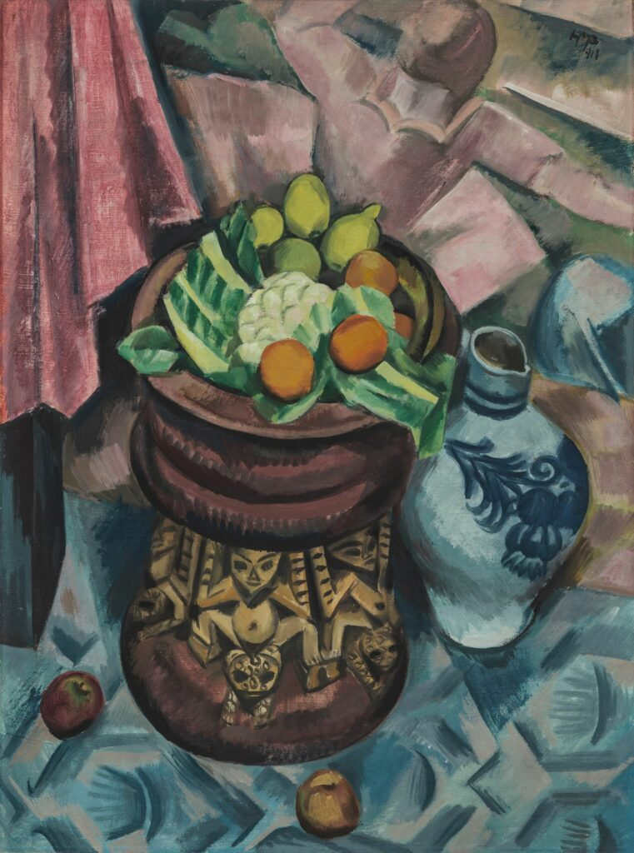
© Pechstein Hamburg/Tökendorf / DACS 2024

In the twentieth century, Modernist art offered new insight into the social fabric of nations driven by global expansion. This was the case in pre-war Berlin, where German artist Max Pechstein experimented with the traditional still life genre to communicate the zeitgeist (spirit) of the time. Germany became a unified country relatively late in 1871 and its leaders became increasingly fixated with obtaining ‘Global Power’ status. Rapid industrialisation, urbanisation, militarisation, and colonial rivalry characterised this period. Yet an iron-fist approach to modernisation also led to the rise of revolutionary Trade Union movements and provocative art groups who posed a threat to the ruling elite.
Pechstein was born in the town of Zwickau (Saxony) in 1881, an area famous for its coal mining industry and centre of Germany’s emerging Trade Union movement. He fell in love with art and nature as a teenager and began an art apprenticeship in 1896 aged only 14. By 1900, Pechstein had been accepted into Dresden’s prestigious Royal Academy of Art, where he stayed until 1907 and developed his skills in painting, furniture design, textiles, interior design, and sculpture. After living and working in Rome and Paris, in 1908 the artist settled in Berlin, Germany’s ‘industrial and commercial centre’. Here he became a prominent member of the Berlin Secession and also consolidated his relationship with the German Expressionist group Die Brücke (The Bridge). Disillusioned by the industrial metropolis, Die Brücke was a provocative and dissident art collective drawn to utopian notions of an ‘untamed’ nature and so-called ‘primitive’ art (a once widely used term now considered derogatory). Over the course of 1912 and 1913, Pechstein painted a number of still lifes, many of which responded to these ideas. Whereas Modernist still lifes have often been considered a ‘relatively neutral basis for formal experiment’, there is also scope to consider their underlying global political currents.
Still Life in Grey depicts apricots, lemons, and a cauliflower arranged on a stool from the grasslands of Cameroon, then a German colony. Two apples lie on a blue tapestry into which horizontal faces evocative of totem masks are woven. A blue and white vase stands to the right and part of a table draped in pink cloth slopes off to the left. In the background, a female figure resembling a ballerina seems to form part of a wall frieze. As with still lifes of the Dutch period, this painting creates an enticing interplay between different textures; the organic forms of the stool, vase, and fruits contrast with the angular forms of the tablecloth and rug. Yet its rapid brushstrokes, bold lines, experimental use of colour, and shortened perspective evidence a clear shift from realism towards abstract expressionism. When in Rome and Paris, Pechstein marvelled at the reverential abundance of nature in old master paintings, something he felt modern Germany lacked. Although this painting still suggests nature’s abundance, the cauliflower in the centre – an uncommon vegetable in still life paintings – seems to tease at the precious ‘exotica’ of early still lifes at a time of rapid industrial and agricultural expansion. In turn, this unconventional vegetable draws attention to the more the traditional citrus and apricots, which have transformed from foreign luxuries into relatively common urban commodities. The blue and white vase bears a design typical of a Saxon pottery. Whereas blue and white pots in seventeenth-century still lifes were usually rare artefacts imported from China, this Saxon vase shows the assimilation of such styles into local society.
The Cameroonian stool, meanwhile, evidences a Netherlandish legacy of collecting and displaying in still lifes ‘exotic’ foreign objects (a contemporary term now considered problematic due to its ‘othering’ effect). Pechstein may have seen this item displayed at Dresden’s Ethnographic Museum – a site where colonial artefacts were now available to the masses rather than exclusive to the curiosity cabinets of the elite. That said, it was also fashionable at this time to exhibit ethnographic objects in the home as a statement of cultural avant-gardism, and it is possible that Pechstein saw two Cameroonian stools below his own paintings in the study of Wolfgang Gurlitt, Pechstein’s art dealer in Berlin. Die Brücke artists were disenchanted by the industrial streets of Berlin and enthralled by the idea of ‘a lost Paradise, a sort of Utopia untouched by the corruption of modern civilisation’. Although Pechstein’s display of this stool might indicate a genuine Modernist fascination with ‘primitive authenticity’, it also presents a problematic endorsement of colonial ownership over these objects and places. The German avant-garde felt a sense of superior intellectuality when they claimed to understand the abstract style and meaning of ‘primitive’ art, and the German imperial ‘land grab’ at this time ultimately led to sentiments of power. Today we can flip such notions on their head. Rather than offer a one-way projection, the presence of Indigenous art forms in such works played an integral part in the development of Modernist paintings as hybrid sites of transnational influence and cultural exchange.
Whereas the seventeenth-century Dutch elite generally appreciated colonial lands from a distance, by the twentieth century, settler colonialism was significantly facilitated by the development of steam power. Pechstein had an idealised dream of moving to the ‘distant tropical world’ of Palau, then a German colony east of the Philippines. He had read Paul Gauguin’s paradisical account of Tahiti (‘Noa Noa’) in 1907 and was likely influenced by the ‘aggressive’ German advertisement of the South Seas as ‘the most beautiful spot on earth’. Aware that he needed to raise money, Pechstein entered a financial contract with Gurlitt who sold the artist’s works and paid him a monthly salary. By 1914, it was Pechstein’s commercial success in Berlin that enabled him to set aboard a steamship to Palau with his wife, where he stayed and painted until conscripted to fight in 1916. If Pechstein sought a harmonious and nature-oriented world, he nevertheless relied upon imperial and industrial power structures to get there.
***

Fernand Léger (1881 – 1955), Composition with Fruit,

Paris, 1938
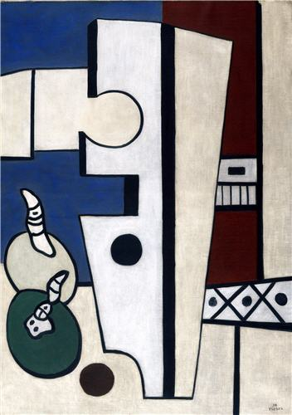
© ADAGP, Paris and DACS, London 2024

Twenty-five years later in inter-war Paris, Fernand Léger pushed the aesthetic boundaries of still life painting even further. In 1900, at the age of 19, Léger moved from rural Normandy to urban Paris to pursue a career as an architectural draftsman. It was here that he met artists such as Robert Delaunay and became part of an organised group of ‘Cubists’ – artists using tubular and cubed forms (often inspired by industrial structures) to draw attention to the flatness of the canvas and further revolutionise the principles of pictorial representation. As a socialist, Léger believed that his ‘Machine Aesthetic’ could offer the working classes a moment of relief from the fast pace of modernity. The artist’s experience of trench warfare during World War One only heightened this interest in crude and utilitarian mechanical structures – a theme treated with a sustained focus until the artist’s death in 1955.
In Composition with Fruit, Léger’s abstract, block-like forms hint at an industrial cityscape. The monochrome zig-zag structure alludes to the metal girder of scaffolding, the balcony railing and window hint at the façade of a tower-block apartment, and the imposing jig-saw-like shape in the centre stands in for a missing part of an industrial puzzle – perhaps a piece of machinery or a workers’ tool. The two oval forms with stalks (or worms) suggest the fruit of the title, and Léger’s subtle use of shading and oblique lines gives the work a general sense of depth. As with Pechstein’s Modernist work, this contrasting arrangement of organic and inorganic objects in a receding space functions as a provocative play on the traditional still life genre. Formalist art historians such as Clement Greenberg have argued that such Modernist paintings should be appreciated at face value in purely abstract terms. Yet an investigation into the mobile narrative contexts behind this artwork also contributes crucial insight into Léger’s representational subject matter and style.
During the inter-war period, Paris was conceptualised by contemporaries as a ‘spectacle’ – a site of cosmopolitan capitalist sensationalism. The rise of ‘Americanism’ promised freedom, prosperity, and a never-ending array of new luxury goods marketed through ‘visually aggressive’ advertisements on the streets. All manner of consumer products – interlaced with materials from all over the world – were available in dazzling shop windows and department stores. In 1924, Léger wrote that the city is ‘so dynamic that a “slice of life” seen from a café terrace is a spectacle’. The artist also acknowledged that he was living in an increasingly ‘geometric order’ and sought to negotiate ‘the architecture of the mechanical’. He was both agitated by the harshness of the urban streets (as Pechstein was) and intrigued by their ‘plastic’ beauty. On the one hand, Composition with Fruit evidences the artist’s attempt to rationalise the overwhelming materialism of the metropolis through a formal aesthetic logic; his slick surfaces, clean lines, and calm colouration offering an ordered refuge from urban cacophony. On the other hand, Léger’s harsh edges and bleak atmosphere seem to critique the city’s cold aesthetic. It was becoming increasingly clear that capitalist ‘freedom’ was founded upon harsh factory work, and Karl Marx’s socialist theory of ‘alienated labour’ was frequently invoked in cultural discourse. Moreover, the Great Depression of the 1930s meant that factories had to cut back production and lay off workers, all whilst politics shifted sharply to the right. In this context, Léger’s use of dull monochrome and unsentimental industrial structures also expresses a stark sense of disenchantment towards the modern city’s fragmented fabric and hierarchical economic structure.
The organic fruits and worms seem out of place in this industrial order. Perhaps Léger was questioning where such ‘humble’ forms belong in a cityscape of mechanical surfaces and mass consumerism. Chong and Kloek acknowledge that in Dutch still lifes:
‘…insects, worms, and snails are almost ubiquitous accessories … and seem to act as observers and onlookers. In environments usually devoid of human participants, they are surrogates for viewers … feeling the surfaces of various materials, and viewing objects from different viewpoints.’
Perhaps Léger’s worm-like forms act as observers and onlookers in industrial Paris, viewing the city from the ground and feeling its varied surfaces. They could even function as ‘surrogates’ for the labouring classes who shifted through these imposing structures on a daily basis. The work also communicates a sense of decay. Against a mechanistic backdrop, the organic fruits, leached on by these worms, evoke the ephemerality of the natural versus the immutable force of the mechanical. As with Dutch and Flemish still lifes, they suggest the transience of time and perhaps warn against excess. Yet compared with the refined paintings of de Heem and Tassaert, Léger shifts our focus from the abundance of the interior table to the processes and appearance of the exterior world. Impacted by industrial capitalism, frenzied consumerism, and economic depression, he created art for the working classes and provoked a cautionary message about the materialism of his age.
***

Conclusion
Together, these four ‘Unstill lifes’ offer insight into changing attitudes towards globalisation, capitalism, and consumer culture over time. In the seventeenth century, de Heem and Tassaert expressed enthusiasm for the burgeoning wealth and abundance of Dutch and Flemish elite society. Detached from the reality of imperial exploits, they celebrated new ‘exotic’ consumer goods and immortalised imperial collecting practices with minute attention to detail. By the twentieth century, Modernist artists experimented with the still life genre to communicate their own cosmopolitan experiences. As Germany strived for ‘Global Power’ status, Pechstein’s expressionist painting evidenced a continued fascination with foreign objects and lands. In inter-war Paris, by contrast, Léger’s industrialised still life evoked the overwhelming and classist nature of an urbanity underpinned by materialism. When placed in dialogue with one another, these artworks shed light on the inextricable links between political formation and material exchange over time, and (knowingly or not) touch upon a spectrum of consequences caused by global capitalism. In today’s world of interlinked geopolitical networks, such artworks can push us to consider the complexity of where things come from, and ultimately question the cost of their extraction, production, and circulation in an ever-growing consumer economy.

Bibliography
Berger, J., ‘Léger’ in F. Frascina, C. Harrison, D. Paul (eds)., Modern Art and Modernism: A Critical Anthology, New York, 2018, pp. 239-41
Chong, A. and Kloek, W., Still-Life Paintings from the Netherlands 1550-1720, Amsterdam, 1999
Donington, K., ‘Cultivating the World: English country house gardens, “exotic” plants and elite women collectors, c. 1690-1800’, in J. Stobart (ed.), Global Goods and the Country House: comparative perspectives, 1650-1800, London, 2023, p. 381-403
Egmond, F., ‘The garden of nature: visualizing botanical research in Northern and Southern Europe in the 16th century’, in J. Ferdinand (ed.), From Art to Science: Experiencing Nature in the European Garden, 1500-1700, Treviso, 2016, pp. 18-33
Farago, J., ‘A Messy Table, a Map of the World’, New York Times (May 8, 2022), https://www.nytimes.com/interactive/2022/05/08/arts/design/dutch-still-life.html [accessed 27/03/2024]
Flynn, D. O., and Giráldez, A., ‘Born with a “Silver Spoon”: The Origin of World Trade in 1571’, Journal of World History, 6, 1995, pp. 201-21
Fulda, B. and Soika, A., Max Pechstein: the Rise and Fall of Expressionism, Berlin, 2012
Greenberg, C., ‘Modernist Painting’, in C. Harrison and P. Wood (eds), Art in theory, 1900-1990: an anthology of changing ideas, Oxford, 1992, pp. 754-60
Greenberg, C., ‘Master Léger’, in F. Frascina, C. Harrison, D. Paul (eds)., Modern Art and Modernism: A Critical Anthology, New York, 2018, pp. 109-14
In Full Bloom, exh., The Mauritshuis, The Hague (10 February 2022 - 6 June 2022), https://www.mauritshuis.nl/en/what-s-on/exhibitions/exhibitions-from-the-past/in-full-bloom/
Kershaw, I., To Hell and Back, St Ives, 2015
Léger, F., ‘The Machine Aesthetic’ (Paris, 1924), in Functions of Painting, London, 1965/73, pp. 52-71
Léger, F., ‘The Spectacle’ (Paris, 1924), in Functions of Painting, London, 1965/73, pp. 35-48
Little, W. (ed.), ‘Trade, Colonialism, and the Origins of Global Society’ in Introduction to Sociology, Third Canadian Edition, Victoria B.C., 2023, pp. 537-49
Marx, K., ‘Machinery and Modern Industry’ in Capital, Volume I, Hamburg, 1867, p. 460
Merriam, S., Seventeenth-Century Flemish Garland Paintings, Oxford, 2012
Moore, A., Flis, N. and Vanke, F. (eds.), The Paston Treasure: Microcosm of the Known World, New Haven/London & Norwich, 2018
Powell, C., ‘Locating Early Modern Women in the Public Sphere of Botany: Agnes Block (1629-1704) and Networks in Print’, in Early Modern Low Countries, 4, 2020, pp. 234-58
Smith, C., ‘Hermann Max Pechstein, Still Life in Grey (1913)’, podcast transcript, The Barber Institute of Fine Arts website (uploaded 2023).
Sontag, S., ‘Posters: Advertisement, Art, Political Artifact’ (1970), p. 196, quoted in K. Carter, ‘The Spectatorship of the “Affiche Illustrée” and the Modern City of Paris, 1880-1900’, Journal of Design History, 25, 2012, p. 11
‘Still Life’, Tate, https://www.tate.org.uk/art/art-terms/still-life
Swan, C., Rarities of These Lands: Art, Trade, and Diplomacy in the Dutch Republic, Princeton, 2021
Wallert, A. (ed.), Still Lifes: Techniques and Style, Amsterdam, 1999
Zuroski, E., ‘Nautilus Cups and Unstill Life’, Journal 18, 3, 2017, https://www.journal18.org/issue3/nautilus-cups-and-unstill-life/

Wallert 1999, p. 4.
Chong and Kloek 1999, p. 39.
Ibid., p. 11.
The Protestant Reformation involved the critique and destruction of representational religious imagery across sixteenth-century Europe.
Farago 2022 [accessed 27/03/2024]
Ibid.
Chong and Kloek 1999, p. 80.
Swan 2021, p. 24.
Today, the term ‘Golden Age’ is considered problematic as its positive associations with peace, prosperity and opulence obscure the historical reality of a period also characterised by colonialism, poverty, war, and slavery.
Chong and Kloek 1999, p. 170.
Ibid.
Moore, Flis and Vanke 2018, p. 99.
Zuroski 2017
Ibid.
Farago 2022
Ibid.
Ibid.
Little 2023, p. 541.
For example, see Flynn and Giráldez 1995, pp. 201-21.
Chong and Kloek 1999, p. 28.
Ibid., p. 73.
Merriam 2012, pp. 5-6.
Farago 2022.
Egmond 2016, p. 25.
Chong and Kloek 1999, p. 115.
Donington argues this point in relation to British society in Donington 2023, pp. 384-85. Similar research is being done in the Netherlands; see Powell 2020, pp. 234-58, or the recent exhibition at The Mauritshuis, The Hague, In Full Bloom, 2022.
Ibid.
Kershaw 2015, p. 10.
During the ‘Scramble for Africa’ in 1884, Germany built the world’s third-largest colonial empire after the British and the French. The German empire encompassed parts of several African countries, including territories in present-day Burundi, Rwanda, Tanzania, Namibia, Cameroon, Gabon, Congo, Central African Republic, Chad, Nigeria, Togo, and Ghana. Germany also acquired northeastern New Guinea, Samoa and numerous Micronesian islands (including Palau) before the turn of the century.
Fulda and Soika 2012, p. 61.
‘Still life’, Tate, https://www.tate.org.uk/art/art-terms/still-life
A comparable stool is in the New Art Gallery, Walsall (No. 1973.321GR), see: https://collections.thenewartgallerywalsall.org.uk/ objects/5049/cameroon-wood-stool?ctx=97b7445e-1696-484c-be91-b8c886391284&idx=0.
Fulda and Soika 2012, p. 133. When in Paris, Pechstein was also influenced by Picasso, Matisse, and Derain, and their use of African sculptural forms in Modernist art.
Smith 2023.
Fulda and Soika 2012, p. 71.
Smith 2023.
This idea is articulated in Wilhelm Worringer, Abstraction and Empathy (1906), which was widely read by German Expressionists at the time.
M. Pechstein, Erinnerungen (1960), p. 22, quoted in Fulda and Soika 2012, p. 32.
Fulda and Soika 2012, pp. 133-36. The authors also note that the reality of Palau would have been far less ‘untouched’ than Pechstein had hoped, what with the mining exploits of the German South Seas Phosphate Company and the punitive raids of station chief Wilhelm Winkler (pp. 145-49).
Ibid.
Léger 1965/1973, pp. 52-71; Berger 2018, pp. 239-41.
Greenberg 2018, pp. 109-14; Greenberg 1992, pp. 754-60.
Sontag 2012, p. 11.
Léger 1965/1973, p. 35.
Ibid., pp. 52-53.
Ibid., pp. 42-46.
Marx 1867, p. 460.
Chong and Kloek 1999, p. 28.

