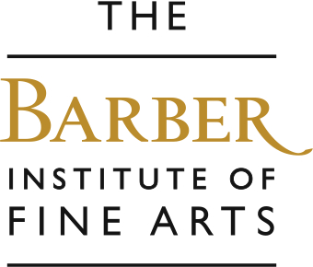

Still Life and Symbolism
We will look at a selection Renaissance paintings and then Baroque and Modern still life paintings from Italy, Holland, France and Britain. You will compare compare more traditional or realistic paintings with modern, colourful abstract paintings. We discuss the meaning of colours, musical instruments, animals, plants, fruit, objects and people in art.

Aims….
To encourage pupils to… improve looking, listening and speaking skills through interaction, investigate the meaning of objects and symbols in paintings, explore shape, form and style, look and record from first-hand observation, use their imagination.
Outcomes…..
Improved knowledge of artists and how to look at and talk about art, and the understanding of how to draw a still life.

Some works we explore and a few questions we ask…

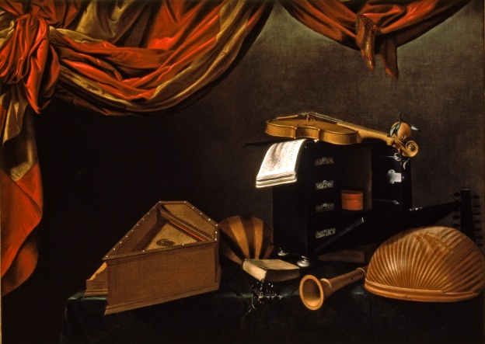

Evaristo Baschenis Still-life with Musical Instruments, 1660
- What kinds of objects can you see?
- Why might some people think this is a photograph?
- Why do you think the strings are broken on the violin and the lute?

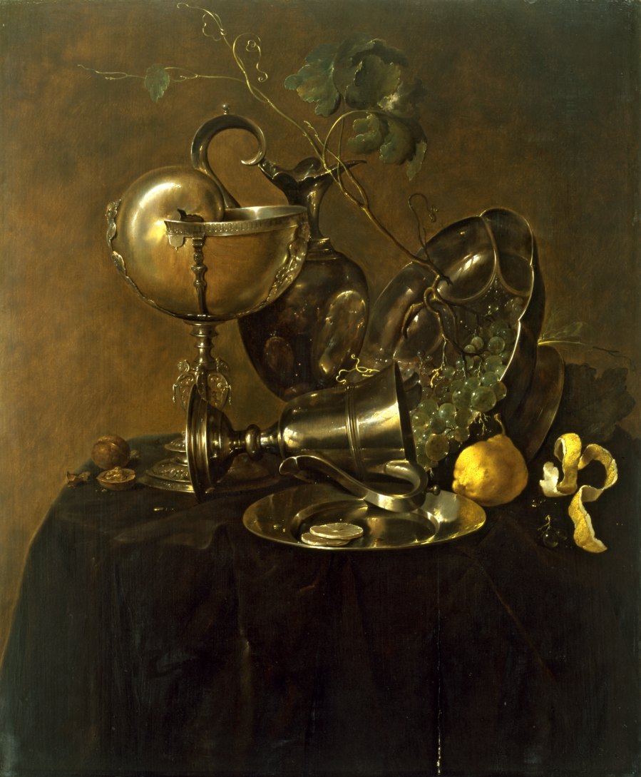

Jan Davidsz de Heem, Still Life with Nautilus Cup, 1632

- What fruits can you see?
- Did the artist find these objects like this or did he arrange them carefully?
- Who do you think would have used objects like this?
- If the artist had found these objects this way, what could have just happened?

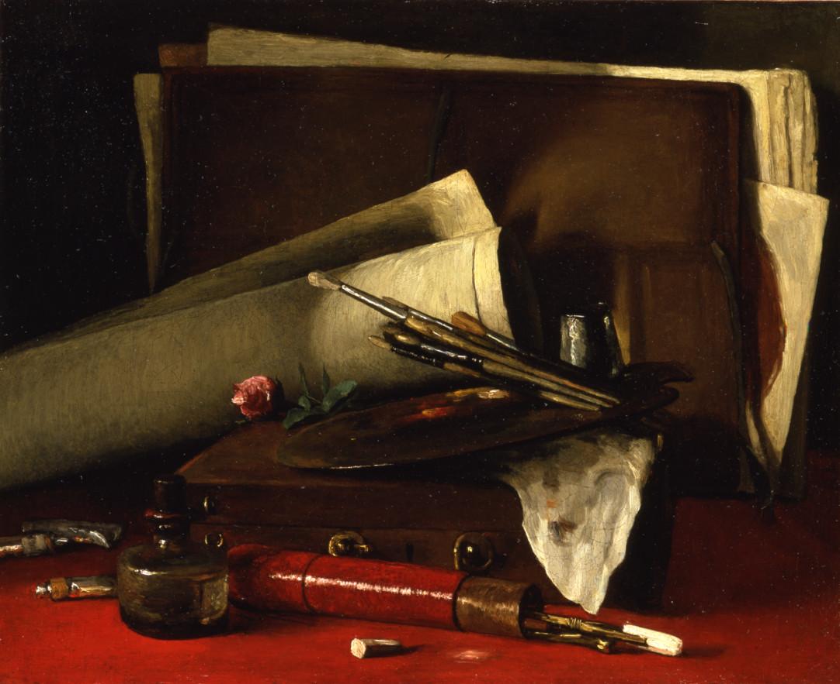

Francois Bonvin, The Attributes of Painting, 1879

- What kind of person would have used objects and materials like these?
- When do people buy roses for each other? What do they symbolise?
- If you look closely at the portfolio, it’s possible to make out a face – look carefully. We don’t know if this was intentional, or coincidental. What do you think?

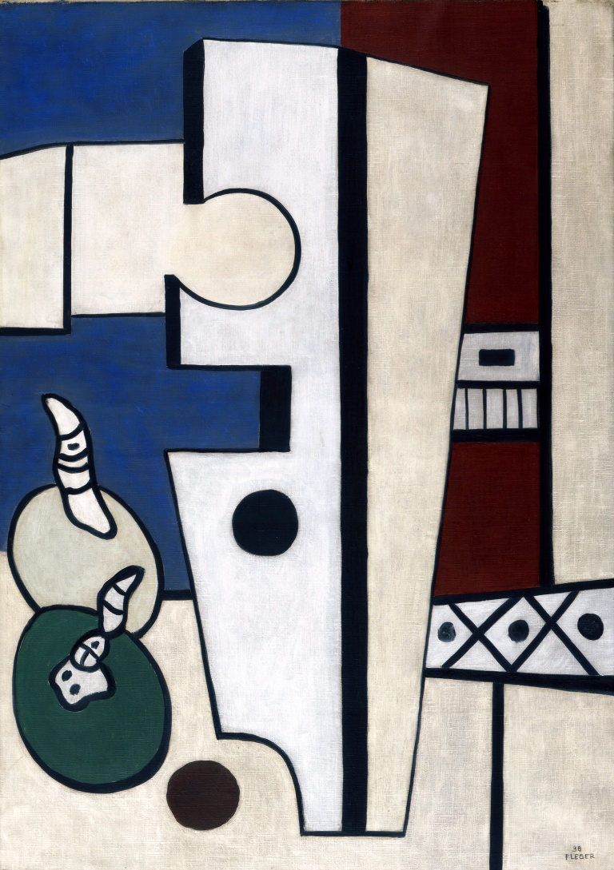

Fernand Leger, Composition with Fruit, 1938

- What could the round objects at the bottom left of the painting be?
- What other shapes and patterns can you see?
- What is a 3D square called? A 3D circle?

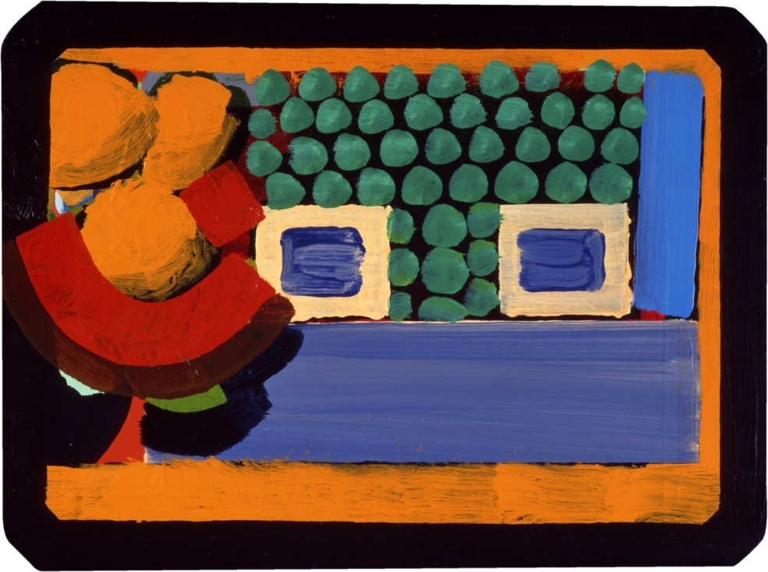

Howard Hodgkin, Artificial Flowers, 1975

- Can you see any flowers in this picture?
- What can you see? What shapes and colours can you see?
- How long do you think it took the artist to make this painting?

The work we then make…

You can opt for a drawing workshop where pupils draw a still- life painting in the galleries, or draw still life objects from observation in the classroom, or we take a more realistic still-life and transform it into an abstract drawing in the style of Leger or Hodgkin.



