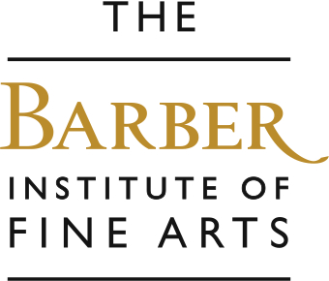

Sculpture
We will focus on animals or people in this workshop exploring 3-dimensional form. In groups, children can discuss different materials and methods of making sculpture by looking at many different objects, including an Ancient Egyptian head and a bronze rhinoceros called Miss Clara. Children can then model their own portrait or rhinoceros in self-drying clay.

Aims….
To encourage pupils to… improve looking, listening and speaking skills through interaction, explore shape and form and the qualities of different sculptural materials, explore the stories and histories behind the sculptures.
Outcomes…..
Improved knowledge of sculptures and sculptors, understanding of how different sculptures are made and how to manipulate clay to create their own sculptures.

Some works we explore and a few questions we ask…

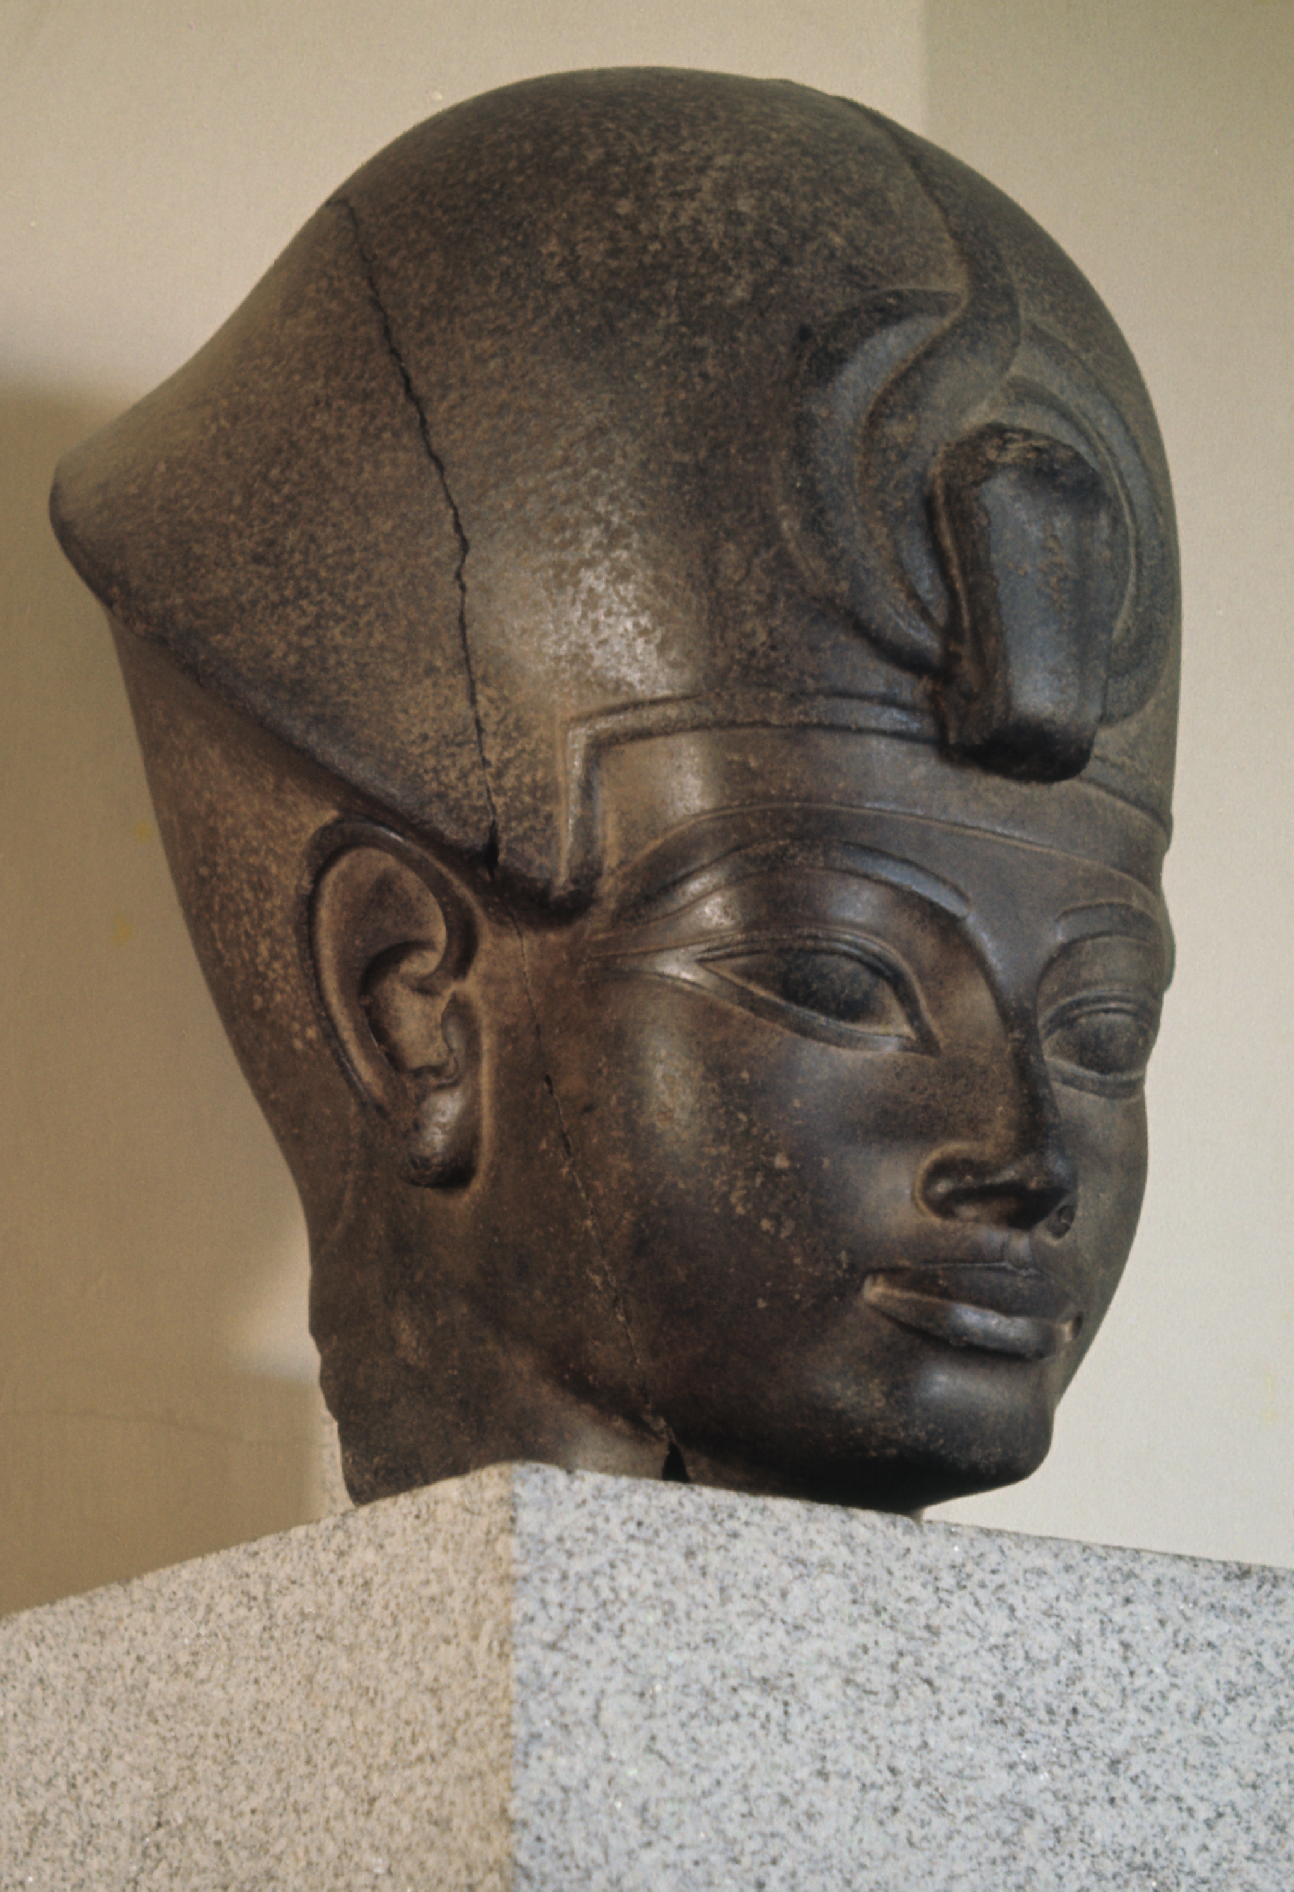

Egyptian, Head of Amenhotep III, 15th/14th century

- What do you think this sculpture is made of?
- How was this sculpture made?
- How old do you think this sculpture is?
- Was it made for the Barber Institute? Where do you think it was originally displayed?

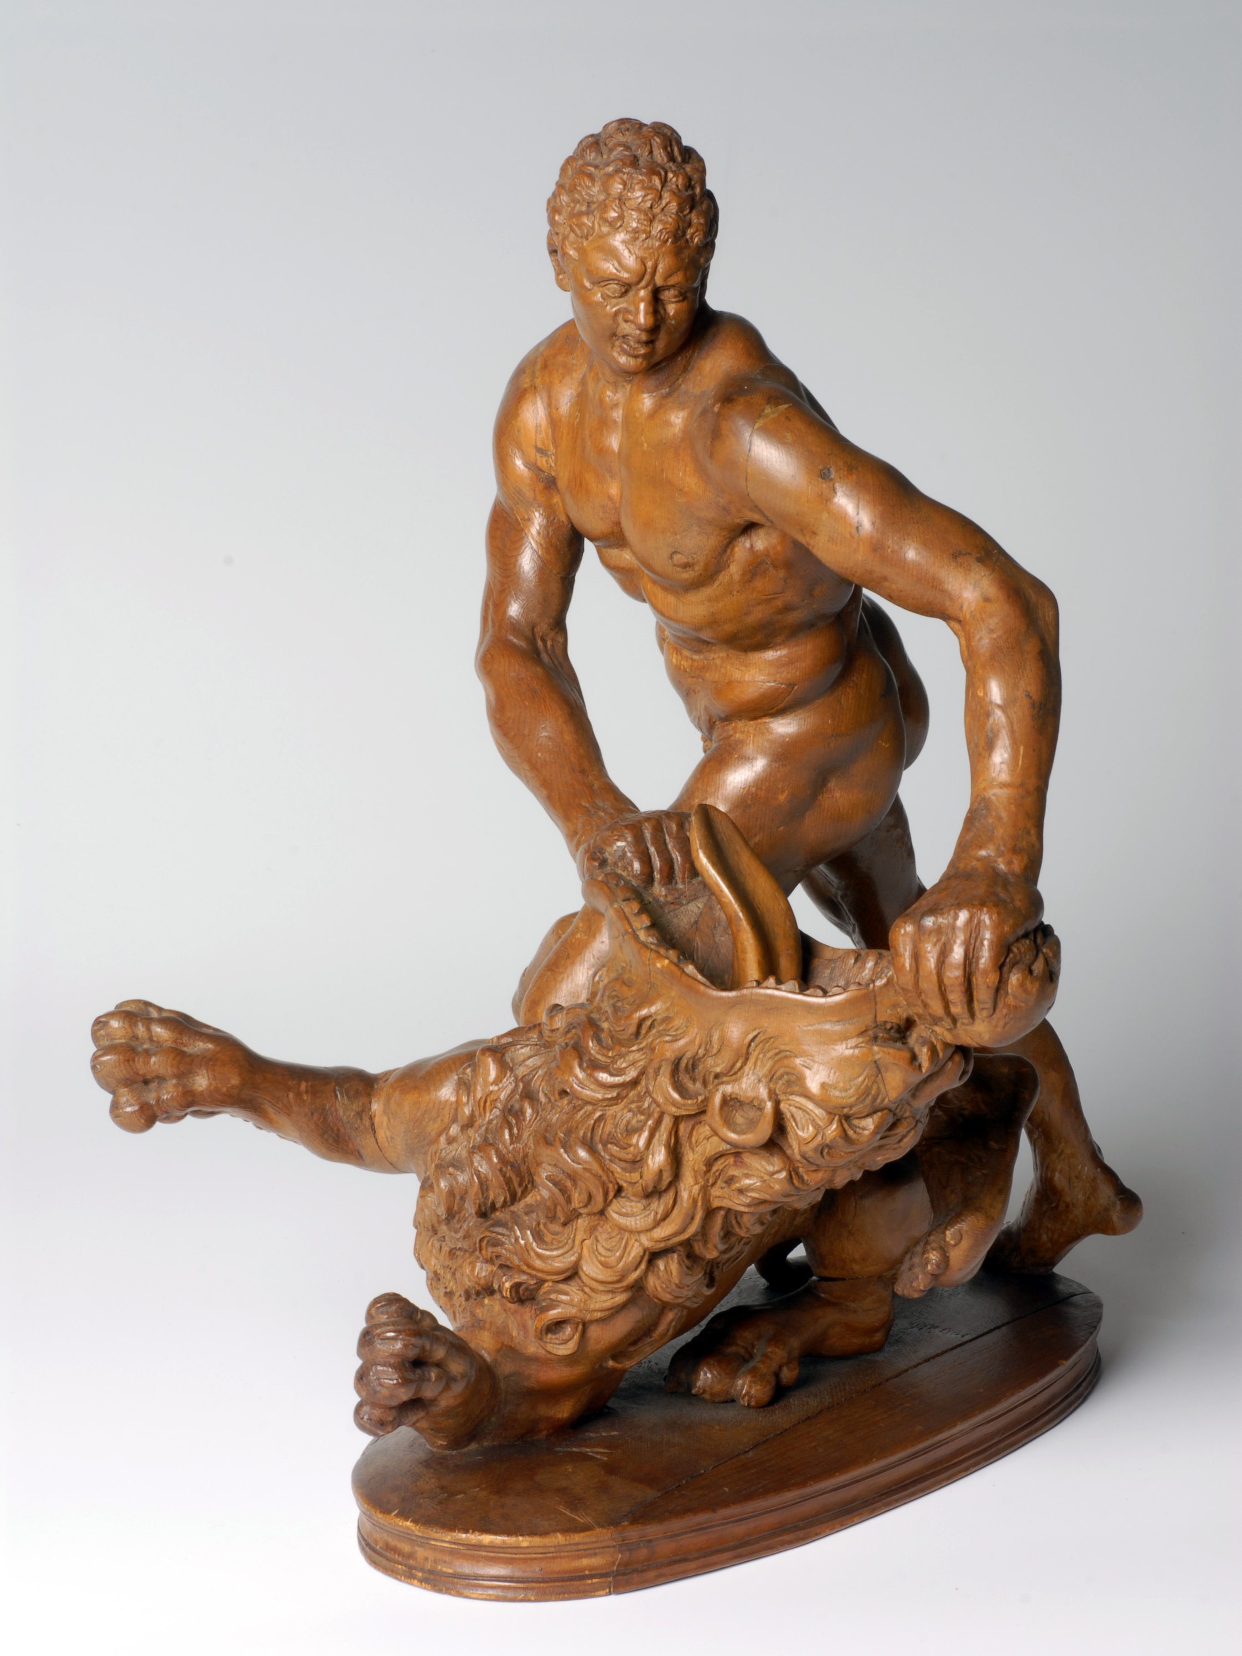

After Stefano Maderno, Hercules and the Nemean Lion, 1621
- This sculpture is a brown colour, what is it made of?
- What is the man doing in this sculpture?
- What do you know about Hercules?

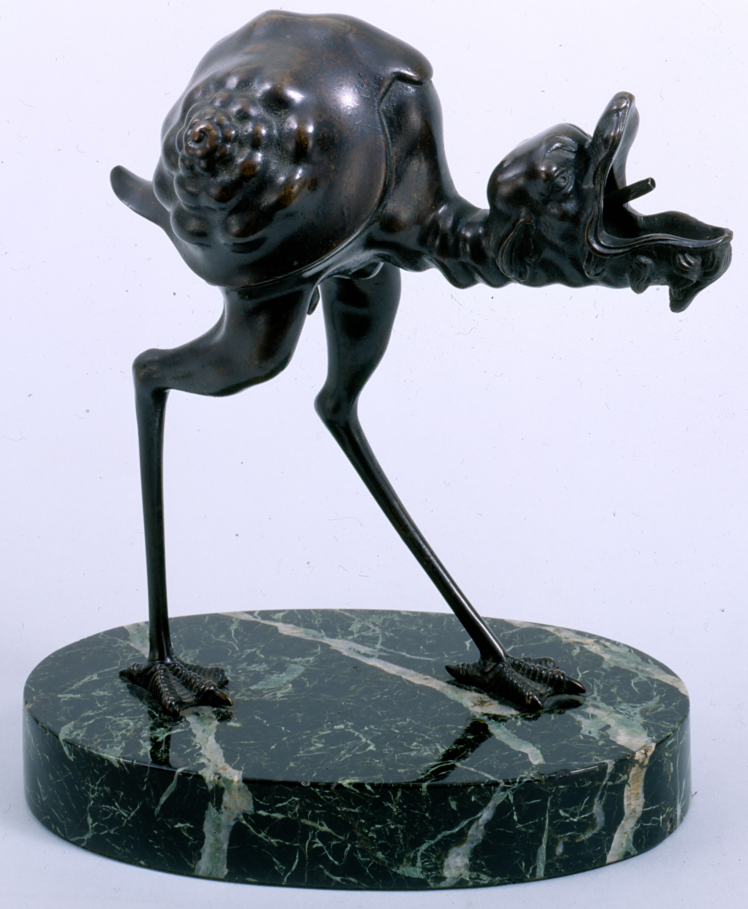

After Arent van Bolten, Lamp in the form of a Grotesque Bird, 1633

- Have you ever seen an animal like this before?
- His legs look like which animal? His body looks like which animal?
- This was not just a sculpture, it was a useful object. What would people have used this for – use your imagination?

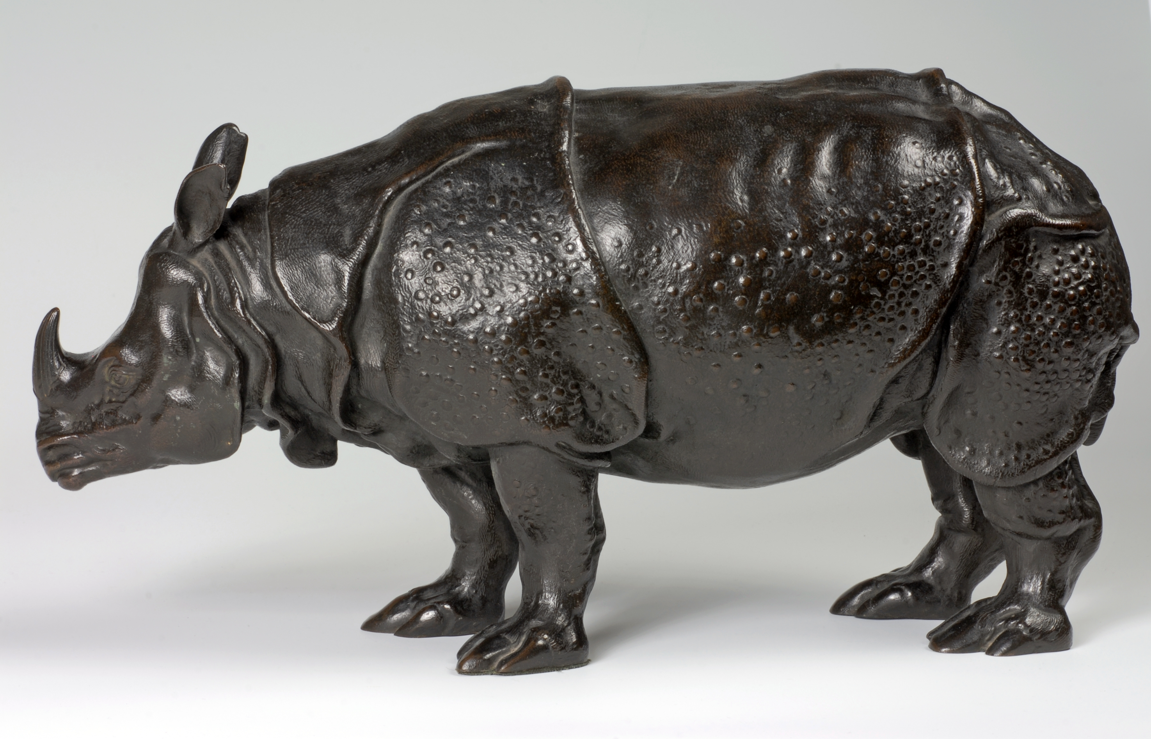

Unknown sculptor, A Rhinoceros, c1750

- What is this animal?
- Have you ever seen one before?
- What is this sculpture made of?
- 250 years ago when Miss Clara was brought over to Europe from India, what do you think people thought of her?

The work we then make…

Make clay rhinos or clay heads. Pupils learn how to create sculptures using simple 3D shapes, and attaching each shape by carefully scoring each surface and mixing clay with water to make parts stick together. Pupils use self-drying clay and clay modelling tools.



