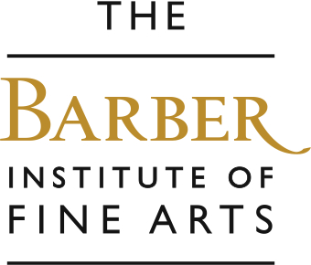

Portraits
In this popular workshop we will have lively discussions about what portraits are and how they can be found all around us in everyday life. We will look at portraits from the Renaissance to Modernism, and children can dress up as an artist and his model in an interactive session. Then they will learn how to draw and colour a portrait by looking at one of the Barber masterpieces, with guidance from our gallery educators.

Aims….
To encourage pupils to… improve looking listening and speaking skills through interaction, explore expressions and symbols in paintings, explore colour and technique, look and record from first-hand observation, improve acting skills through role-play, and basic language skills in French and Italian.
Outcomes…..
Improved knowledge of artists and how to look at art, and the understanding of how to draw a portrait.

Some works we explore and a few questions we ask…

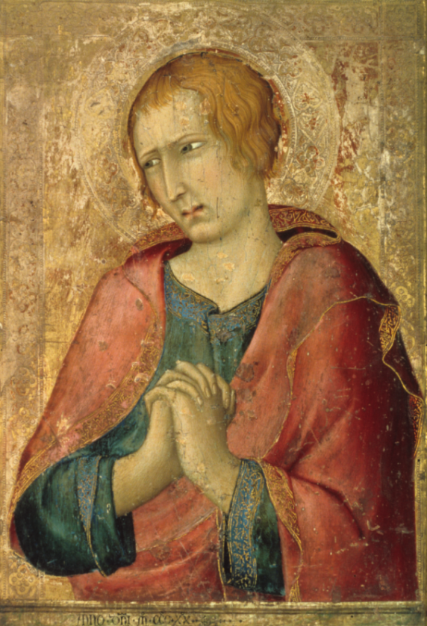

Simone Martini St John the Evangelist, 1320

- How can we tell a person’s feelings and emotions from their face?
- Where do we find the story of Jesus? So why might Saint John be so sad?
- Renaissance artists did not have paint, like us, that they could buy in tubes or bottles; they had to make their own paints. Where do you think they found red colours? Where did they find blue?

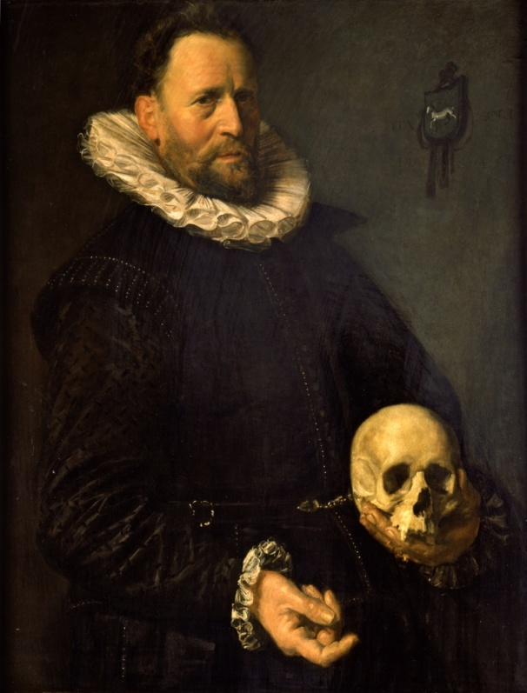

Frans Hals, A Portrait of a Man with a Skull, 1610-14
- What is this man wearing?
- Do you think this was a wealthy man? Why?
- Why is he holding a skull? What do you think this means?

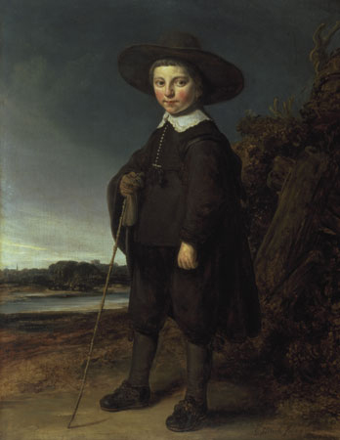

Govaert Flinck, Portrait of a Boy, 1640
- It has similar dark colours, but compare this painting to the one by Hals, what’s different?
- Do you think this little boy was rich or poor?
- He is holding a bamboo cane which tells us that he came from a wealthy family. Why is that?

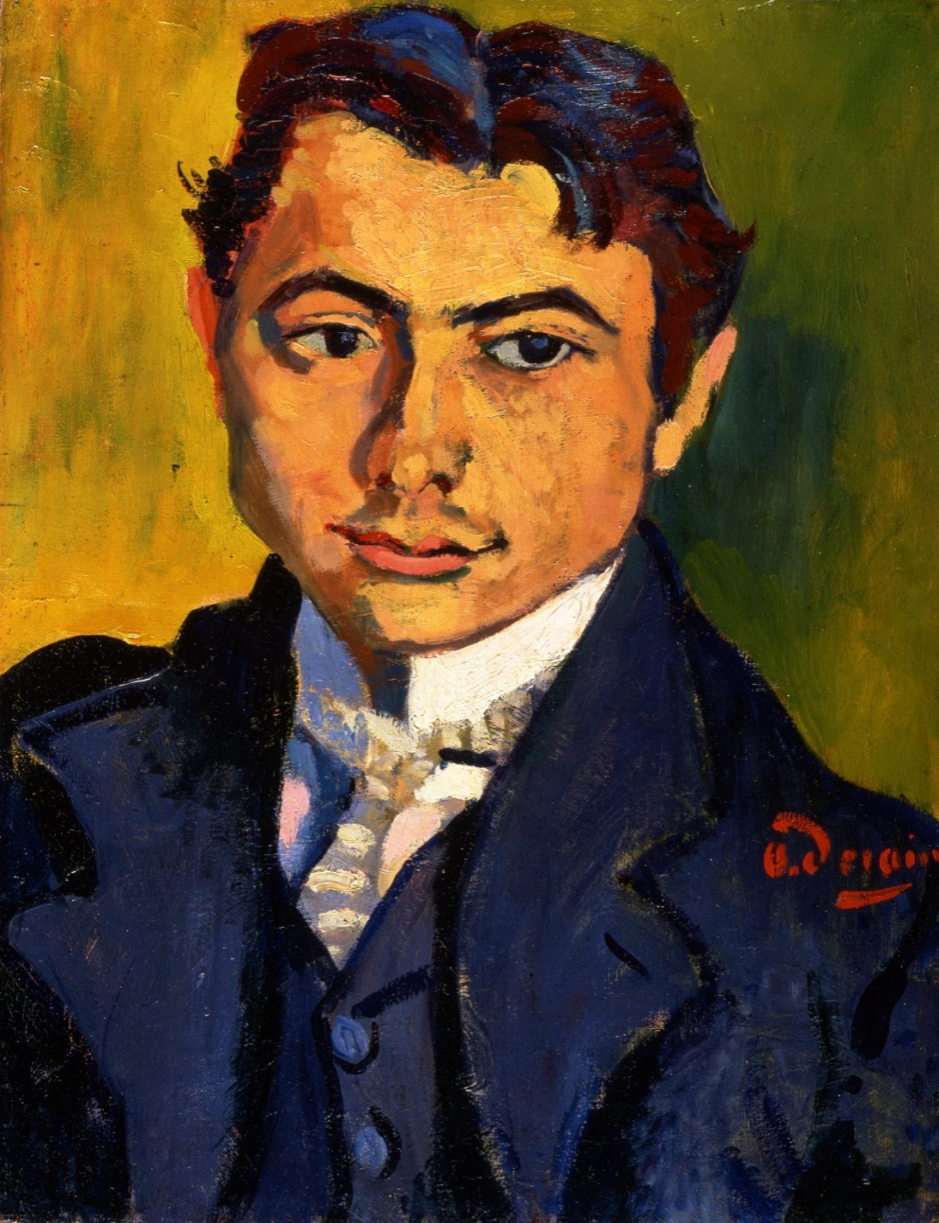

Andre Derain, A Portrait of Bartolomeo Savona, 1906
- What colours can you see in this painting?
- What is unusual about the man’s hair?
- How do you say ‘hello’ in French, and Italian?
The work we then make…

We teach pupils how to draw a portrait. We focus on Andre Derain’s Fauvist painting A Portrait of Bartolomeo Savona, working from direct observation in the gallery. We add coloured pencils to create bold and colourful drawings. Alternatively you could opt to do a collage workshop.



