

Landscapes
Journey imaginatively through time and across continents to discover the different ways artists have painted landscapes. You will looks at the wilderness, pastoral landscapes, the countryside, erupting volcanoes, seascapes and night-time scenes.

Aims….
To encourage pupils to: explore different artists, improve looking, listening and speaking skills through interaction, explore space, colour and tone, use imagination, investigate materials, look and record from first-hand observation.
Outcomes…..
Improved knowledge of artists and how to look at art and talk about art, improved knowledge of geography and geology (how volcanoes are formed!) and the understanding of how to draw or print.

Some works we explore and a few questions we ask…

- What is a landscape? How many different kinds, or types, of landscapes can you name?

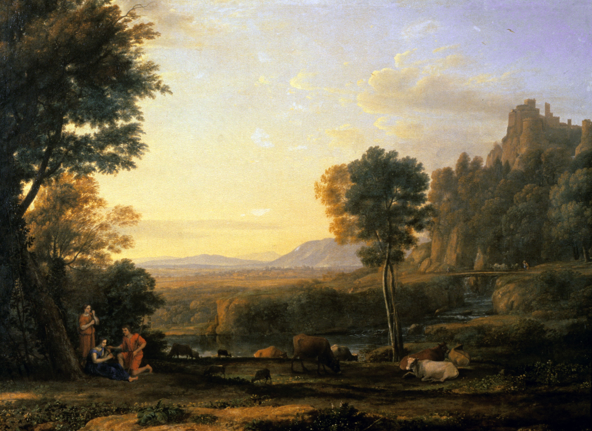

Claude Lorrain, Pastoral Landscape, 1645

- What do you see in the foreground, the middle-ground, the background?
- Artists have two techniques to give ‘perspective’ or depth - to show that some things are close to us and some things are far away in the distance. What are these two things?
- Do you think this painting was based on a real place that the artist visited, or was it from his imagination?
- How does this landscape make you feel? Calm, anxious, peaceful, angry?

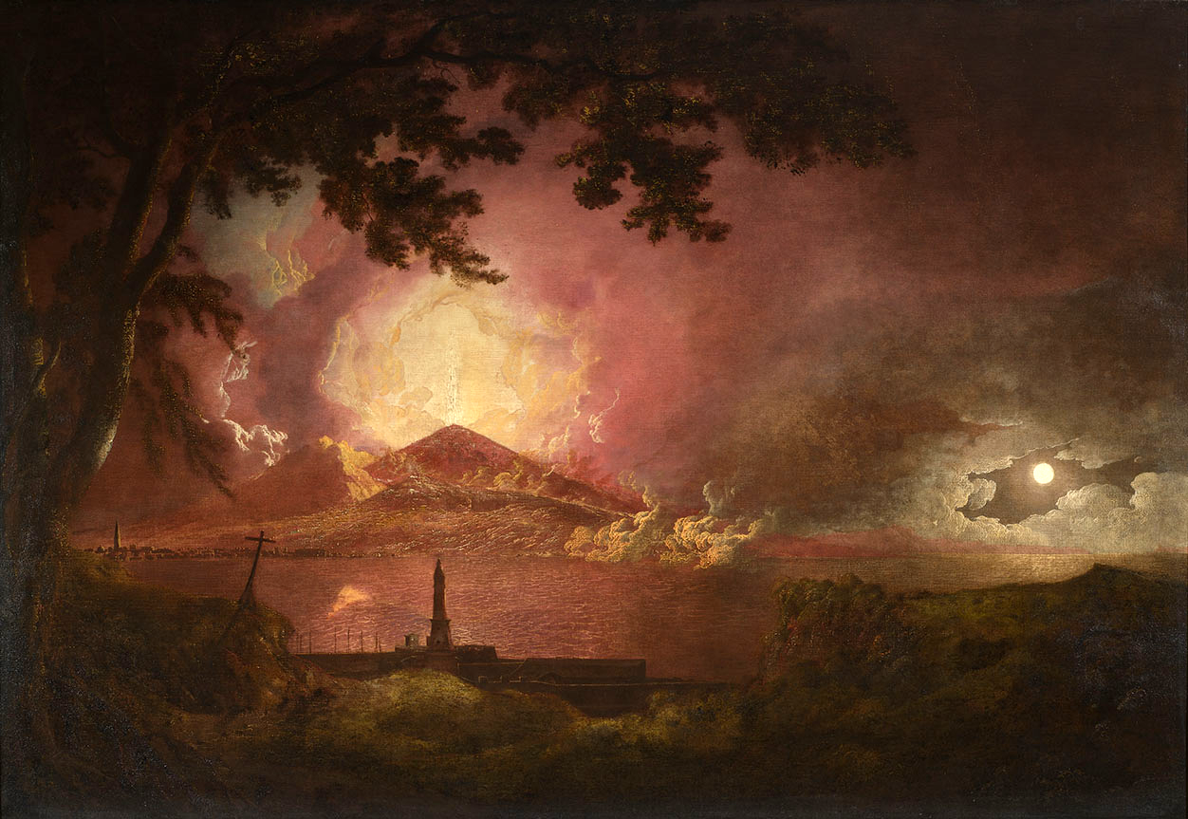

Josephy Wright of Derby, Vesuvius in Eruption, 1777-80

- A volcano’s eruption is a natural disaster. Can you name any other natural disasters?
- What colour is the sea? It’s not blue!
- What time of day do you think it is?
- How would you describe the atmosphere of this painting?

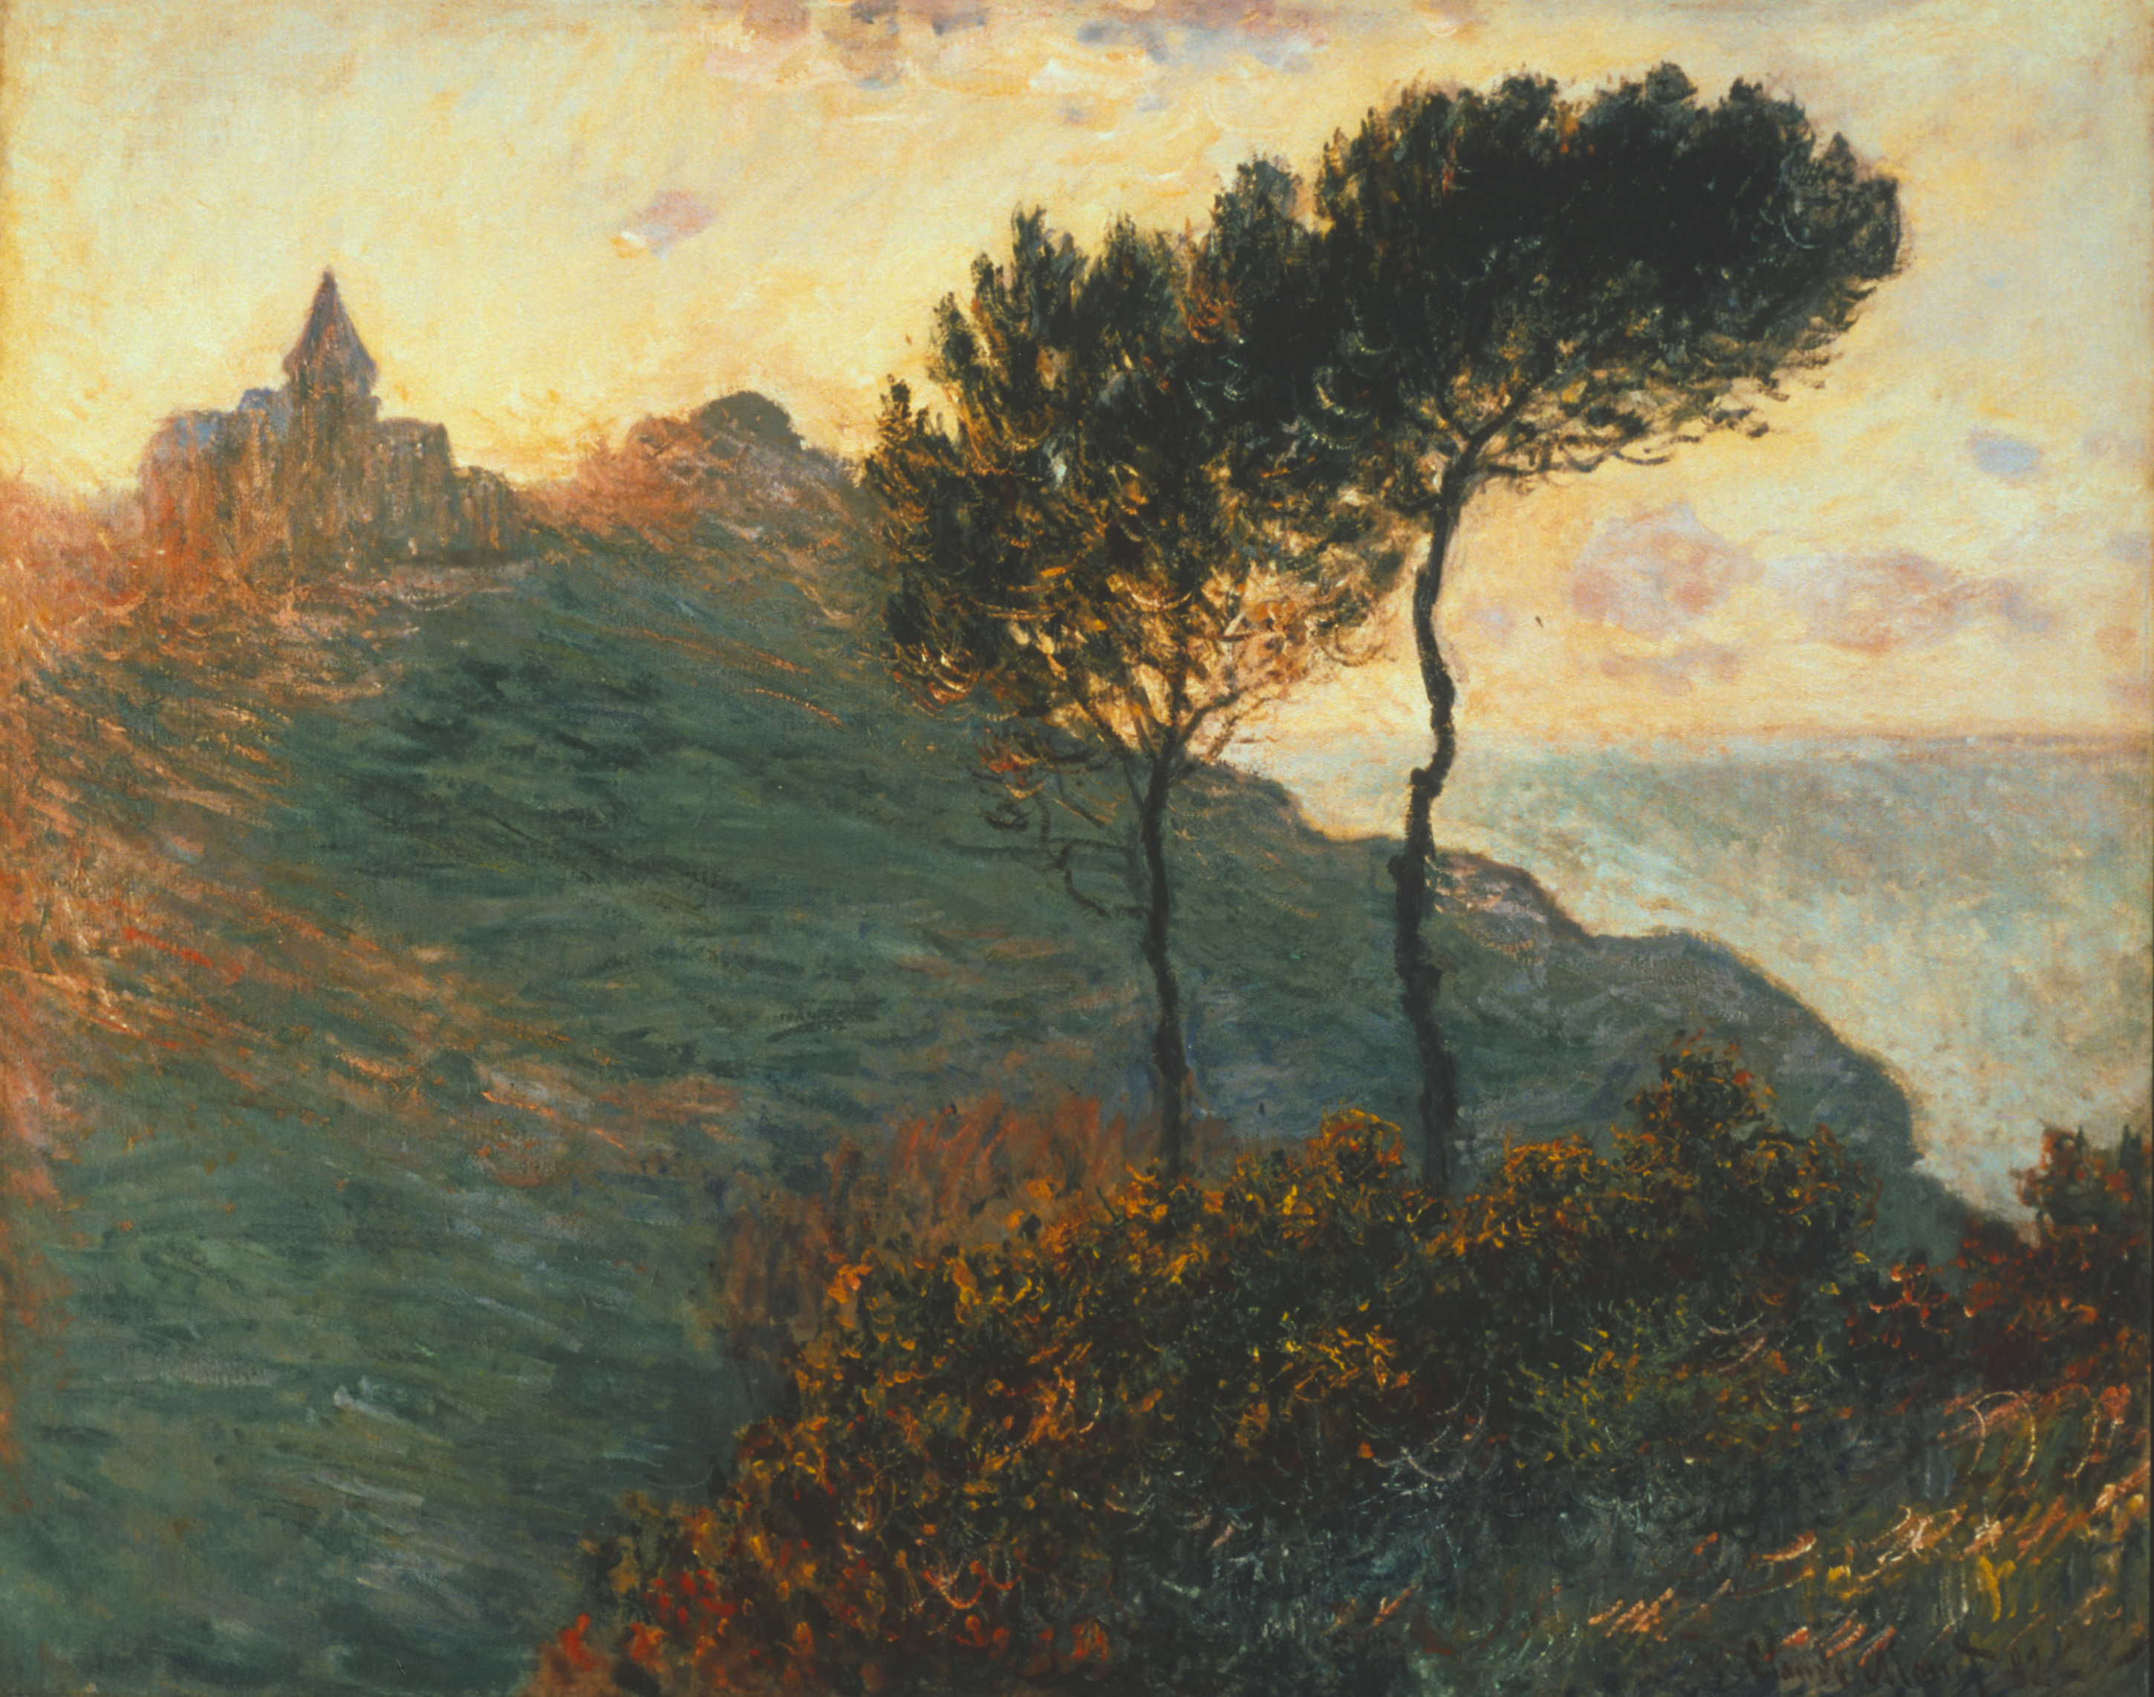

Claude Monet, Church at Varengeville, 1882

- How is this painting different from all of the other landscapes we have looked at?
- What colours do you see in this painting?
- Do you think Monet painted this quickly or slowly, and why?

The work we then make……

You can choose a drawing workshop, drawing a work from direct observation in the galleries, or a printing workshop where you can produce your own poly-block print.



