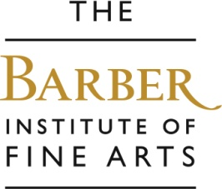

Nursery and Reception Offer
Sessions for nursery and reception last up to 90 minutes and can take place in the mornings or afternoons. We can offer an ‘Animal Stories’ workshop or a ‘Funny faces’ workshop which includes a fun tour around the gallery, followed by a clay-making activity. We recommend you add story-telling to these sessions at an additional cost.

Aims… to encourage children to explore art, to enjoy learning in the gallery environment, to improve looking, listening and speaking skills, to investigate and play with clay.
Outcomes… an enjoyable learning experience, an understanding of the feel of clay and what you can create using it.

Funny Faces
Children explore portraits, expressions and feelings by looking at paintings and sculptures of people through the ages. They then model some funny faces using clay.

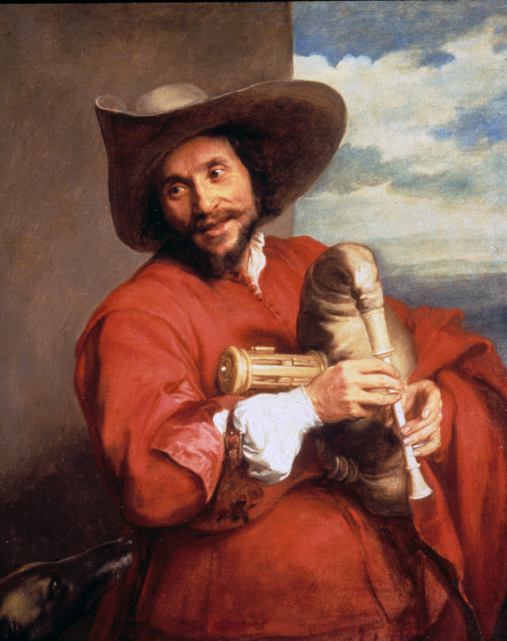

Anthony van Dyck, Portrait of Francois Langlois, 1637
- Does this man look happy or sad?
- What is he doing?
- Have you ever played an instrument?
- Name some instruments you know!

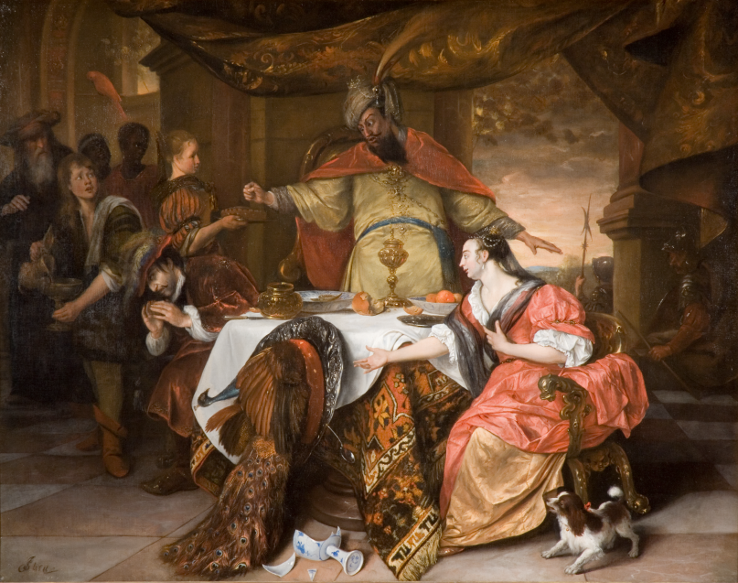

Jan Steen The Wrath of Ahasuerus, 1671-3
- The King is in the centre, his wife Esther is on the right and Haman is on the left. Who do you think is the baddie?
- Copy what Haman does!
- Do you think the King is pleased or angry?
- Make a fist and look angry like the King!
- Can you see any animals in this picture?

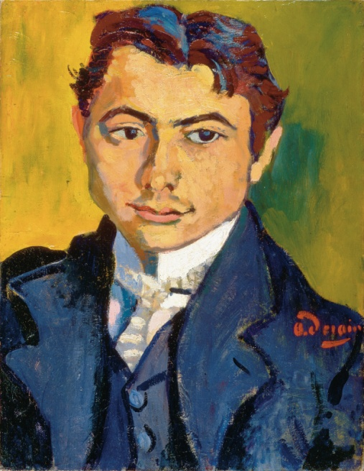

Andre Derain, A Portrait of Bartolomeo Savona, 1906

- Look at Bartolomeo’s hair – how many different colours can you see? Do you think it was this colour in real-life?
- This man is from a country beginning with ‘I’. Do you know any countries beginning with ‘I’?
- The artist is from a country that would say ’bonjour’ for hello. Do you know where he came from?
- Andre Derain was a ‘Fauvist’. This means ‘wild beast’ in French. What noise would a wild beast make?

The work we then make….

We make clay heads. Children learn how to create sculptures using simple 3D shapes, and attaching each shape by carefully scoring each surface.
Pupils use self-drying clay and clay tools. We provide plenty of helpers to assist the children.

