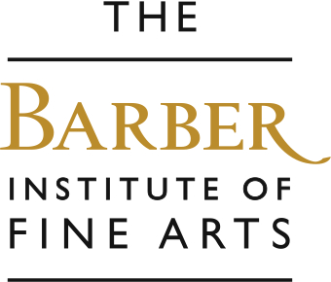

Nursery and Reception Offer
Sessions for nursery and reception last up to 90 minutes and can take place in the mornings or afternoons. We can offer an ‘Animal Stories’ workshop or a ‘Funny faces’ workshop which includes a fun tour around the gallery, followed by a clay-making activity. We recommend you add story-telling to these sessions at an additional cost.

Aims… to encourage children to explore art, to enjoy learning in the gallery environment, to improve looking, listening and speaking skills, to investigate and play with clay.
Outcomes… an enjoyable learning experience, an understanding of the feel of clay and what you can create using it.

Animal Stories
The Barber is full of animals. Children can go on an adventure to find all kinds of animals hiding in the paintings, prints and sculpture as well as hearing stories about animals in the artwork.

Some works we explore and a few questions we ask…

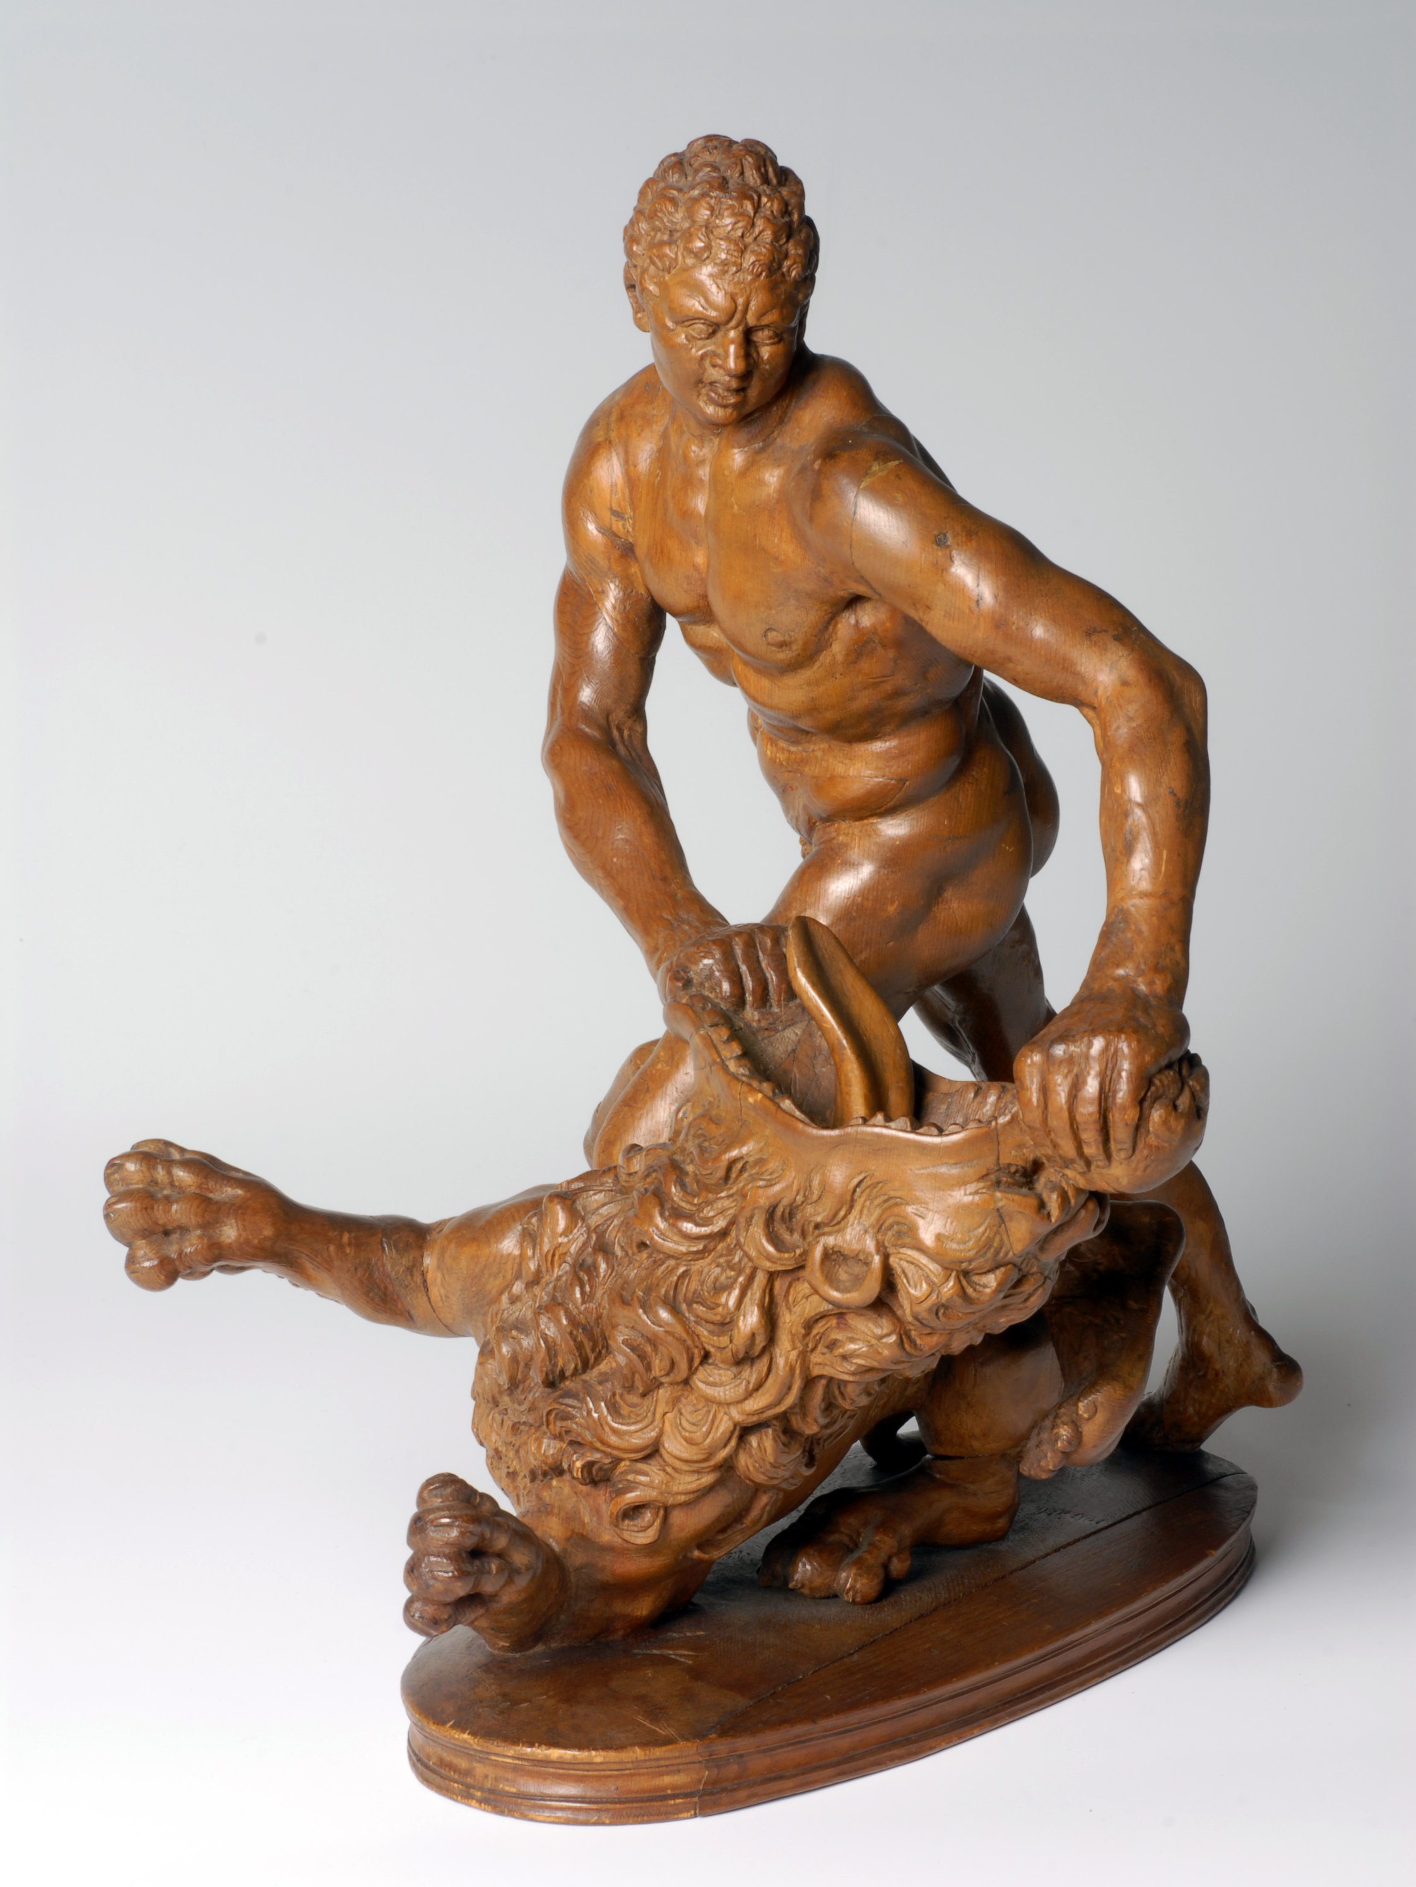

After Stefano Maderno, Hercules and the Nemean Lion, 1621
- This is a man called Hercules who was half man half God.
- He is fighting an animal that goes ‘Roooaaaaaaaarrrrr’. What is it?
- Can you roar like a lion?
- This sculpture is a brown colour, what is it made of? Clue: they are big and you find them outside!

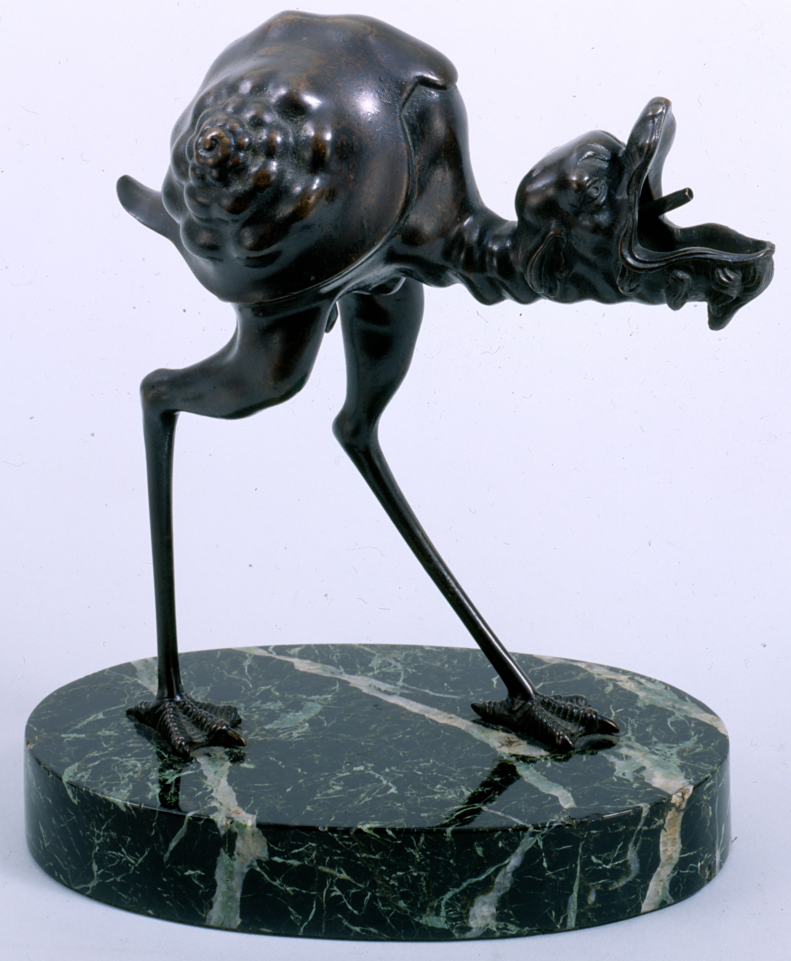

After Arent van Bolten, Lamp in the form of a Grotesque Bird, 1633
- Have you ever seen an animal like this before?
- His legs look like a bird? What noise does a bird make? His body looks a snail shell. What do snails do?

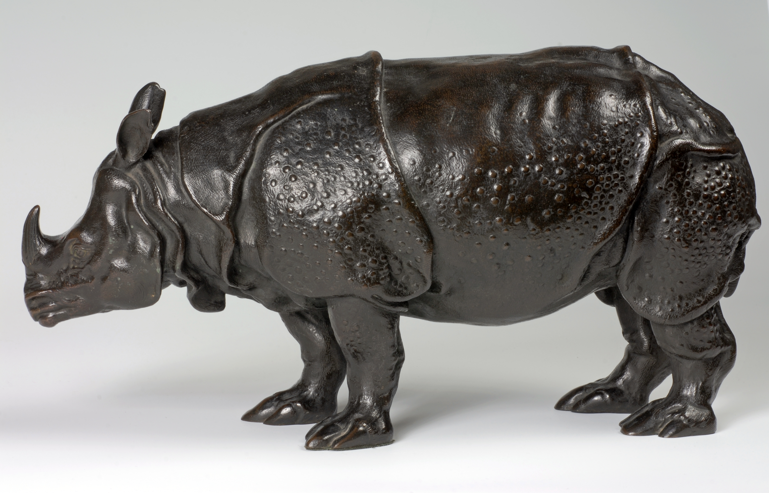

Unknown sculptor, A Rhinoceros, c1750
- What is this animal?
- Have you ever seen one before?
- This sculpture is made of a metal called bronze. Do you think it is hard or soft?
- Do you think it is cold or warm?
- 250 years ago when Miss Clara was brought over to Europe from India, what do you think people thought of her?

A few other animals we point out…

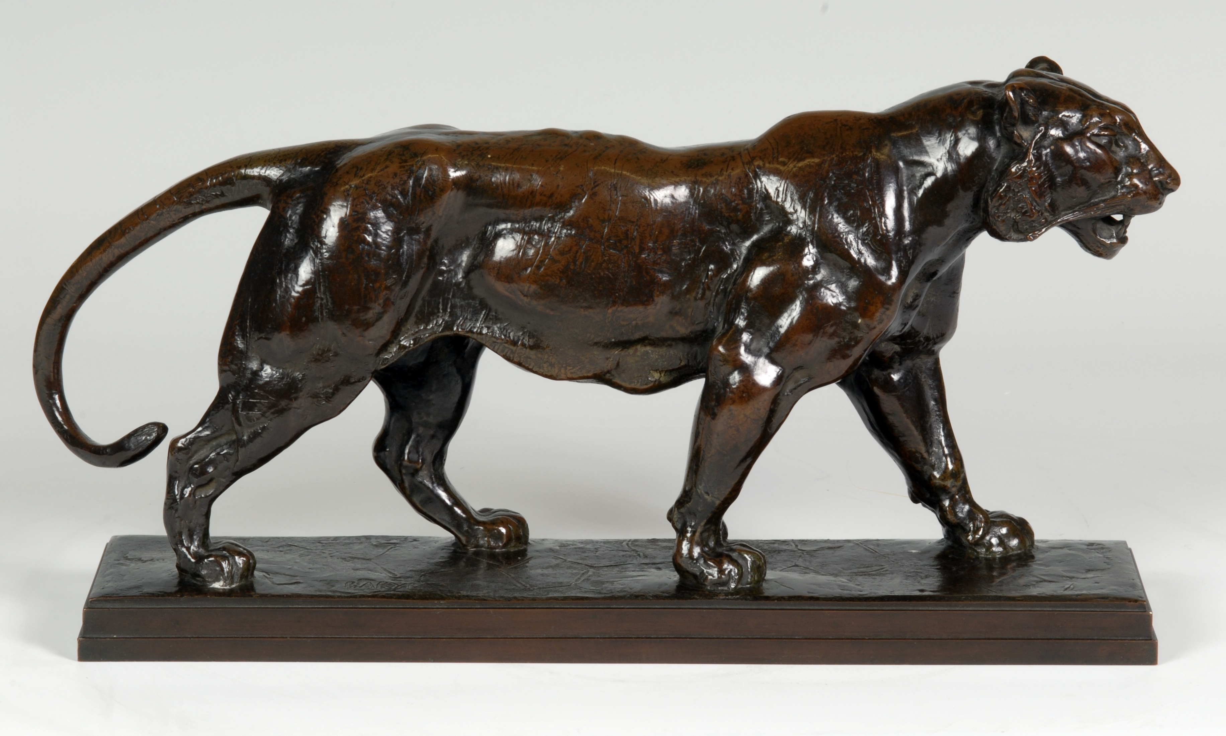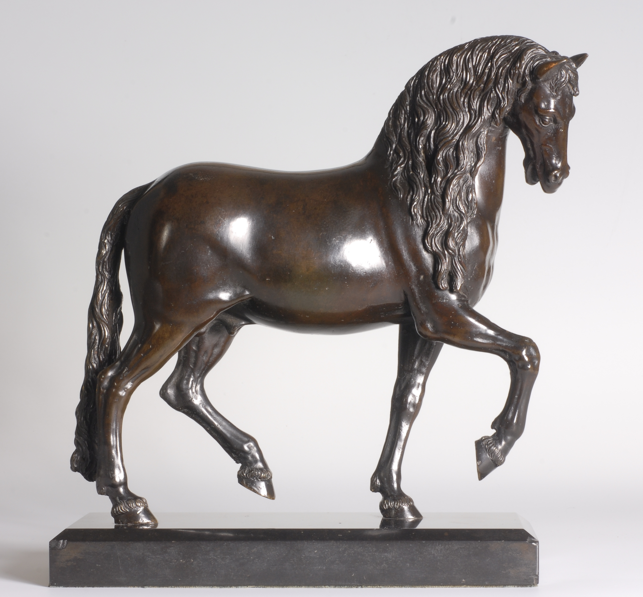
After Barye, Tiger Walking, 1836 Pietro Tacca, A Pacing Horse, 17th century

The work we then make…

Make clay rhinos. Pupils learn how to create sculptures using simple 3D shapes, and attaching each shape by carefully scoring each surface and making ‘special glue’ using water mixed with clay. Pupils use self-drying clay and clay tools. We provide plenty of helpers to assist the children.



